St George Community Housing

Annual Report 2022
<pp>1

Welcome
We acknowledge the traditional Aboriginal owners of the lands on which we operate and provide homes for people.
We acknowledge and pay our respects to past, present, and future Aboriginal elders, people and nations. We recognise Aboriginal people as having the world’s oldest living, continuous culture with unique languages and spiritual relationships to the land and seas.
St George Community Housing (SGCH) is strongly committed to practical action aimed at building the physical, cultural, spiritual, and family wellbeing of Aboriginal people through our role as a community housing provider. We renew our determination to listen and to learn from Aboriginal people, to recognise the important contribution they make, and to offer a first-rate service that responds to the diversity of Aboriginal people and their communities.
<pp>2

Great places, thriving people, connected communities.
21-22
<pp>3

About this report
Our Annual Report 2022 has been prepared with reference to the International Integrated Reporting Framework. Our first integrated report considers our strategy, performance, and operations in the context of environmental, social and governance factors that materially affect our efforts to create value for our customers, our partners, our team members, and the communities we serve.
This report is prepared by our Corporate Affairs, Impact and Communications and Finance teams in collaboration with all Head of Departments. Sponsored by the Group CEO, the Board approve this report. The Group Chair and Group CEO have authorised this report for publication on 31 October 2022.

Materiality
SGCH considers a matter material if senior management and those charged with governance believe it could significantly impact the value created and delivered by SGCH in the short, medium, and long term.

<pp>4

Contents
01 Overview
Our purpose
FY21/22 Snapshot
Group Chair’s report
Group CEO’s report
Our presence
02 Approach
Operating context
How we create value
Our business model
Strategy
Customer service standards
ESG commitment
ESG overview
Areas of focus
Stakeholders
Materiality assessment
03 Performance
Customers
Supporting our customers
Social Impact
Continuous improvement
Safe and sustainable homes
Maintaining homes
New homes FY21/22
People and culture FY21/22
Workforce composition
Financial sustainability
Financial performance
Commercial approach
04 Financial report
Corporate governance principles
Committees
Group structure
Risk
Directors’ report
Discussion and analysis of the Summary Financial Statements
Summary consolidated statement of profit or loss and other comprehensive income
Summary consolidated statement of financial position
Summary consolidated statement of changes in equity
Summary consolidated statement of cash flows
Independent auditor’s report
Directors’ declaration
Content elements

<pp>6

01 Overview
- 02 Approach
- 03 Performance
- 04 Financial report
<pp>7
Cartoon image omitted
<pp>8

Our purpose
Together we provide sustainable, safe and affordable housing as the foundation for our customers to connect to opportunities and build their communities.
<pp>9
- We are more than a housing provider.
- We develop and manage sustainable, safe and affordable homes and work in partnership to realise our vision of great places, thriving people, connected communities.
- We provide services that enable customers to sustain their tenancies.
- We connect customers to services that foster and support their goals.
- We take a place-based approach, working with communities to offer localised activities and engagement that is tailored to their needs and aspirations.
- We create and pursue opportunities with values-aligned partners to increase the supply of housing in Greater Sydney.

About us
SGCH provides sustainable, safe, and affordable housing for almost 11,500 people in more than 7,000 properties across Greater Sydney.

Our history
Founded in 1985, SGCH is a Tier 1 provider under the National Regulatory System for Community Housing. We bring capability and capital to work in partnership with governments, developers, builders, financiers and investors to deliver great places.

Why we exist
Without affordable housing, there are significant barriers for lower income households to participate in and contribute to social and economic opportunities. This increases inequality and risks the long-term success of our communities. Unfortunately, not everyone in Greater Sydney has a place they can call home or access to services and communities that enable them to retain their housing and to thrive. We believe this needs to change.
<pp>10-11

FY21/22 Snapshot
- 11,437 Customers
- 7,068 Homes
- 23 Local government areas
- 121 New homes delivered
- 79% *Overall satisfaction
- 88% First time resolution of Customer Care Hub enquiries
- 236 Staff
  - 70% Female
  - 30% Male
- $3.7b Assets managed
- 1.3b Assets owned
- 288 Homes in development
- $9.5m Surplus
* Tenant Satisfaction Survey 2022
<pp>12

Group Chair’s report
It’s been such a privilege to be part of an organisation renowned for trail blazing, even during challenging times, and this year was no different.
Significant weather events, the COVID-19 pandemic and associated supply and labour shortages caused disruption to all aspects of our lives during 2022, forcing many of us to change where and how we lived and worked. It was a time in which connections between people and working together had never been more important.
Meanwhile, sky-rocketing housing prices, high rents, and cost of living pressures reinforced the importance of our work in helping people on low and moderate incomes, including the vulnerable members of our community, find a stable home and access services and supports.
The year saw changes to the SGCH internal operating environment with new Board, executive and team members and a refined approach to strategic planning and governance, which served to reinvigorate our purpose-led work.
It is also thanks to the leadership of Group CEO Scott Langford and his efforts to cultivate a culture that encourages new ideas and improved ways of doing things. Scott has led the dedicated and passionate SGCH team to achieve a great deal for our customers, including making several service improvements.
Continually looking for ways to better serve our customers, as they use their SGCH homes as a springboard to improve their life circumstances, continues to be our mainstay.
I am very proud to report that SGCH is well placed to pursue further expansion, in partnership with like minded investors and others, to fulfil the opportunity and responsibility to thoughtfully realise government ambitions for urban renewal across Greater Sydney and help even more people in need of social and affordable housing.
I am also pleased this period of renewal has put our impact– environmental, social and governance– firmly in view, as SGCH continues to broaden its footprint in a sustainable way. It’s an exciting time for the organisation.
Partnerships with investors looking for a financial return, while also having a positive and measurable impact, are a key ingredient to SGCH’s ambitions to develop innovative investment models.
Too often it’s our key workers who are driven further away from where they work and study and out of their communities because they are on low and moderate incomes and struggle to afford private market rentals on top of their general living expenses.
One of the partnerships I am particularly excited about is the relationship forged with Lighthouse Infrastructure on the award winning Highline development (by Deicorp) creating 85 brand new homes for key workers in the centre of the Westmead Health Precinct.
The Lighthouse partnership is a blueprint for developing scalable key worker and affordable housing projects and a terrific example of our shared determination to impact positively and measurably on people’s lives. It’s new buildings like Highline that ensure SGCH can provide sustainable, safe, and affordable homes where people want to live.
<pp>13
Increasing the availability of highly sustainable, energy efficient homes that reduce environmental impacts and help to lower household costs for our customers is key to building and maintaining a sustainable housing portfolio.
It has been a great honour to fulfill the role of Director and Chair of SGCH and I look forward to supporting incoming Chair Karen Orvad as she brings her extensive experience and passion to the role.
I am looking forward to seeing the results of our hard work, over many years, with the emphasis on the monitoring and reporting of our impact.
Annette Gallard PSM
"You’re not a number, when it comes to SGCH. They do actually care. They care about all their tenants. I do not know how my property manager deals with me at times because I can get anxious about bills and other things. If I am stressed about something and can’t get the service, they’ll find the service for me. It is nice to be in an area where you’re not alone. There is always someone you can reach out to."
— Katherine, Bonnyrigg
<pp>14

Group CEO’s report
We exist for Dixie
Dixie is a Gooreng, Kabi (Gubbi Gubbi) woman, born in Brisbane. At 18, she moved to Redfern and over time raised her six kids there, she now has 30 grandchildren. Redfern is home. Over the years Redfern became unaffordable for her despite working full time.
Dixie told me she lived a few kilometres away in Petersham for a while, but it was like living on the moon. Place matters. When our Gibbons Street Redfern development was ready for tenants in July 2021, Dixie came home.
It goes without saying it’s been another challenging year as we continued to navigate COVID-19, extreme weather, and economic pressures. This constant test of resilience has impacted our customers and the communities we serve, our team, and our partners.
Our focus remains on our vision of great places, where people thrive, and communities are connected. While this focus– unbroken through the 37-year history of our organisation– remains on providing homes and services for our customers, the ways in which we work must continue to transform and rise to meet new challenges.
This year we reviewed and refreshed our Strategic Plan, and refined our approach to achieving our purpose and vision, guided by our values. We continue to concentrate on financial results that provide benefit for the communities we serve, with a surplus of $9.5m.
We are focused on sustaining tenancies, building and maintaining a sustainable housing portfolio, and being a vibrant, sustainable business. These outcomes are linked to our approach to environmental, social and governance (ESG) factors and in June this year we published our first Impact Report– sharing our performance across a range of ESG metrics. Our corporate reporting suite also includes a Modern Slavery Statement. These efforts reflect our commitment to our customers, partners, and stakeholders to be transparent and accountable for our performance.
I thank our Directors for their strategic insights and guidance as the organisation embraces renewal at the Board level.
In this financial year, we have welcomed Rajiv Viswanathan and Philip Fagan-Schmidt. Following nine years of service, we farewell our Chair Annette Gallard and Vice Chair Victoria Weekes. Annette and Victoria have shaped SGCH in immeasurable ways with their expertise, knowledge and dedication, ensuring SGCH was continually strengthened to provide better outcomes for our customers. On behalf of our customers, our team and our partners, I offer thanks to both Annette and Victoria.
SGCH continues to advocate for strategic reforms to the way social and affordable housing is designed, funded, and managed. We continue to work with different levels of government and the private sector to find sustainable solutions that bring together capital and capability.
In November 2021, we announced an innovative partnership with Lighthouse Infrastructure that is providing 85 homes for key workers in the Westmead Health Precinct. Together, we’ve given essential workers more than our thanks– we’re providing well-located, affordable homes where 93% of tenants reported their lives had improved since living in their SGCH home. Since January 2021, we have delivered 468 homes, including 121 during the FY21/22 financial year. We have a further secured pipeline of 288 units and are working on securing a further significant pipeline with our partners.
Whilst we are proud of this pipeline, we acknowledge it is akin to filling a swimming pool with water comparing it to an ocean of need.
There is more to be done and we will vigorously pursue pathways that mobilise more capital and capability to the task. We want to see a thriving community housing sector capable of meeting the need.
<pp>15
To support our current and future customers, we continue to pursue operational excellence. Following an organisational review in 2021, we have shifted the way we deliver services, most notably across our Customers team. Representing approximately two-thirds of our team, the Customers division now services South Western Sydney and Metro North East Sydney, with integrated teams providing tenancy management, support coordination, community and place engagement and other services. At the start of this financial year, our dedicated Customer Care Hub became operational with the remit to provide a first-call response, where previously customers may have had to wait for a tenancy manager to return their call if they were, for example, attending a home visit. A full year in, we know that 88% of customer enquiries are resolved in their first call. This is making it easier for people to get the answers they need.
We have improved our digital offering with a new website that offers increased accessibility options for our customers and stakeholders. We are investing in technology with a focus on security, efficiency and customer service.
Thank you to our customers for the trust they place in us and thank you to the SGCH team for bringing the best of their expertise and efforts to amplify our impact. With a business head and a social heart, we will keep working with partners who share our values and vision to deliver more places that people like Dixie can call home.
Scott Langford
"Thanks to SGCH, I have a safe house in a beautiful community. Redfern is my home and a place I want to keep working for a long time."
– Dixie
<pp>16-17

Our presence
We house 1 in 430 Sydneysiders.
SGCH owns, manages, and leases more than 7,000 homes across Greater Sydney. We work to ensure our city remains diverse, accessible and a great place for all, no matter your income.
[Note, the following colour-coded information, overlaid on a map, has been converted to a list]
The colour-coded key is:
- [red] Extra large presence > 500 Properties
- [pink] Large presence > 300 Properties
- [green] Medium presence < 300 Properties
- [yellow] Small presence < 100 Properties
[The list of locations from North to South read:]
- [yellow] Hornsby (6)
- [pink] Hunters Hill (338)
- [pink] Willoughby (384)
- [green] Parramatta (162)
- [green] Lane Cove (200)
- [red] North Sydney (508)
  - St Leonards Office
  - Greenway Office
- [yellow] Mosman (2)
- [green] Cumberland (170)
- [yellow] Strathfield (22)
- [yellow] Canada Bay (73)
- [yellow] Burwood (2)
- [yellow] Woollahra (9)
- [pink] Inner West (350)
- [pink] Sydney (455)
  - Redfern Office
- [red] Fairfield (1035)
  - Fairfield Office
  - Bonnyrigg Office
- [yellow] (Waverley (20)
- [red] Liverpool (582)
- [red] Canterbury Bankstown (1076)
  - Riverwood Office
- [pink] Bayside (350)
- [green] Randwick (205)
- [pink] Georges River (332)
  - Hurstville Head Office
- [green] Campbelltown (161)
- [red] Sutherland Shire (626)
<pp>18-19

Connected communities
[A series of images which have captions that read:]
- SGCH’s Placemaking Team with our partner Daystar Foundation in the Bonnyrigg community for the World In One Place event
- Bonnyrigg customers pose with one of the Aboriginal performers at one of our community events
- Kids showing off their face paints at the World In One Place event
- Bonnyrigg’s Youth Council helped manage the sausage sizzle stand at one of our community events
- Hong Xu, SGCH customer in Artarmon, likes to regularly tend to her garden bed
- Tayabeh, SGCH customer in Artarmon, takes tips from greening officers to take care of her garden bed
- The Royal Botanic Garden greening officer teaches SGCH customers how to take care of their plants and veggies
- Children from the Bonnyrigg Public School pose together after their performance at the World In One Place event
<pp>20
- 01 Overview

02 Approach
- 03 Performance
- 04 Financial report
<pp>21
Cartoon image omitted.
<pp>22

Operating context
As the largest community housing provider in Australia’s least affordable city, SGCH offers subsidised rental housing for people on low to moderate incomes.
We are a for-purpose organisation that receives income from rent, and reinvests it to deliver services and increase housing supply.
Social and affordable housing is critical social infrastructure that safeguards the diversity of our communities and supports thriving local economies.
In providing safe and secure homes for very low to moderate income households, our organisation connects people to opportunity, health and wellbeing and supports economic development to contribute to positive change. In addition to housing, SGCH customers can access training, education and employment services. We offer support coordination and referral services for a range of needs including health and financial services. We invest in activities and initiatives that create opportunities for social connection through placemaking.
Housing markets are complex with a range of direct and indirect policy settings impacting housing affordability.
What is clear is that housing in Australia is increasingly unaffordable and this has significant social and economic consequences.
Home ownership is a worthy aspiration and it is often a principal means of creating economic independence. However, before people can consider owning a home they need a rental they can afford. There are also a growing number of Australian households who are faced with barriers that mean they will never own a home. Ensuring a supply of affordable rental properties provides a key stepping stone to home ownership as well as a safety net for those for whom owning a home is out of reach.
As a partner to government delivering services and programs on their behalf, our work reduces the pressure on public resources; SGCH has proven its ability to bring together a range of contributions and attract private investment and capability, coupled with the capacity to deliver and operate much needed social and affordable housing.
<pp>23

Our core offering

Social housing
Social housing is for people on very low and low incomes and includes rental housing that is owned or managed by the NSW State Government, community housing organisations or the Aboriginal Housing Office. It is allocated based on need and priority from Housing Pathways, a common waitlist administered by the government.

Affordable housing
Affordable housing is for people on low to moderate incomes who are working but find it difficult to afford housing that meets their needs (location, price, size) in the private rental market, yet are not eligible for social housing.
[Following is a graph of factors related to housing, which have been converted to a list here. From left to right (x-axis), the factors move progressively up the y-axis, to appear as an increase, which is also indicated by an arrow. This arrow reads:]
Housing affordability solutions should increase supply and build pathways for people to move towards the market.
[From left to right the graph reads:]
- Submarket
  - [red] Crisis
  - [red] Transitional
  - [pink] Social rental (where we focus)
  - [pink] Affordable rental (where we focus)
  - [red] Assisted ownership (between Submarket and Market)
- Market
  - [red] Assisted ownership (between Submarket and Market)
  - [red] Market rental and home ownership.
<pp>24

How we create value
SGCH is in a unique position with the capital, capability, and expertise to work in collaboration with governments, private sector and not-for-profit partners, to create shared value.
We focus on building and nurturing effective partnerships with organisations that are invested in and aligned with our purpose to improve outcomes for our customers and communities.
Embedded across our strategic thinking is our approach to ESG factors. We strive to be a sustainable business that galvanises the efforts and expertise of many people and ensures the community resources we are entrusted with are leveraged to provide more benefit for more people.
"I am forever thankful to SGCH for providing stable housing so I can focus on other matters in life without the stress of share homes, and high market rental prices."
– Tenant Satisfaction Survey 2022
<pp>25

Value Creation Framework
[The following vertical flowchart is comprised of four main sections each of which leads to the next. These four sections are:]
- Key resources
- Our business
- Value created
- Key frameworks and strategies.
[From top to bottom the flowchart reads:]

Key Resources
- [green] Homes
- [pink] Customers and communities
- [orange] People and Organisation
Lead to:

Our business
[A central circle split into four components, with each quarter linking to a separate component on the outskirts of the circle. Each of these four outer components are then linked together.]
Inner circle (clockwise from left):
- Sustaining (links to Purpose, see below)
  - Housing management
- Improving (links to Governance, see below)
  - Housing supply
- Collaborating (links to Strategy and structure, see below)
  - Community and place
- Connecting (links to Culture, see below)
  - Support coordination.
Outer components:
- Purpose (links to Sustaining, see above)
  - Together we provide sustainable, safe and affordable housing as the foundation for our customers to connect to opportunities and build their communities
- Governance (links to Improving, see above)
  - Tier 1 provider National Regulatory System for Community Housing.
  - Registered charity
  - Skilled and independent non-Executive Directors.
- Strategy and structure (links to Collaborating, see above)
  - Strategic plan
  - Group structure
- Culture (links to Connecting, see above)
  - Deliver together with passion and purpose.
Lead to:
- [green] Environmental
  - Value Created
    - More sustainable homes in thriving communities
Attracting new capital into an affordable housing asset class and originating projects.
Providing value for money asset management.
  - Key frameworks and strategies
    - Development and investment, asset management and sustainability.
- [pink] Social
  - Value Created
    - Sustainable tenancies as a foundation for opportunity
Offering efficient customer-centric service
Partnering value for money asset management.
  - Key frameworks and strategies
    - Customer experience and social impact.
- [orange] Governance
  - Value Created
    - A vibrant sustainable business
Aligning high-preforming people, processes and systems
Delivering as a partner of choice at the forefront of a thriving industry.
  - Key frameworks and strategies
    - People and culture, commercial and financial, technology, partnerships and stakeholders, governance and procurement, compliance and safety.
<pp>26

Our business model
Partnerships and collaboration
- [green] More sustainable homes in thriving communities
  - New homes
  - Asset management
  - Innovative investment
- [pink] Sustainable tenancies as a foundation for opportunity
  - Customers
  - Tenancy management
  - Support coordination
  - Housing Plus
  - Placemaking
- [orange] A vibrant, sustainable business
  - People
  - Culture
  - Finance
  - Technology
  - Governance
<pp>27
"I heard a tenant speaking at one of the opening events. He shared about how excited he was to be moving in and I could really see what a difference the project was making. I thought to myself, I’d like to work for an organisation like that. I want to build something that will have an impact."
– Nathaniel, Assistant Development Manager
<pp>28

Strategy

[blue] Purpose
Together we provide sustainable, safe and affordable housing as the foundation for our customers to connect to opportunities and build their communities.

[green] Vision
Great places, thriving people, connected communities.

[pink] Values
With a business head and a social heart, we deliver together with passion and purpose, guided by our values (opposite).
Strategic outcomes | Drivers of success
What we aspire to achieve | What we need to be great at to achieve our desired outcomes
Sustainable tenancies as a foundation for opportunity | - Offering efficient, customer-centric services  - Partnering to create opportunity
More sustainable homes in thriving communities | - Attracting new capital into an affordable housing asset class and originating projects  - Providing value for money asset management
A vibrant, sustainable business | - Aligning high-performing people, processes and systems  - Delivering as a partner of choice at the forefront of a thriving industry
Key strategies that shape and focus our collective effort:
- Customer experience
- Development and investment
- Asset management
- Commercial and financial
- People and culture
- Technology
- Partnerships and stakeholders
Key frameworks that guide decisions, actions and operations to meet the standards our stakeholders expect:
- Safety
- Governance
- Risk
- Data governance
- Social impact
- Sustainability
- Compliance
- Procurement
<pp>29
- Innovation
- Support
- Accountability
- Respect
- Integrity
<pp>30-31

Customer service standards
Our Customer Service Standards represent our commitment to providing excellent customer experience, consistently.
Our Standards support and contribute to our strategy to offer efficient, customer-centric services and aligns with our organisational values: Innovation, Support, Accountability, Respect, and Integrity.
"Very happy overall with the services provided by SGCH. Staff are always pleasant and easy to deal with."
– Tenant Satisfaction Survey 2022
[pink] We provide access to affordable homes and high quality services for you
- We maintain your home to a reasonable standard
- We complete urgent repairs as quickly as possible
- We support you to achieve your desired goals and improve health and wellbeing.
[green] We listen and value your views
- We seek your feedback on our customer service
- We work with you and support services to link you to programs or services that meet your needs
- We support you to form or be involved in your local resident group.
[blue] We explore new and better ways of doing things.
- We provide excellent customer service through continuous improvement and best practice
- We are guided by our customer’s experience when developing new processes.
[orange] We do what we say we will do
- We strive for first time resolution
- We finish what we start. We keep the customer informed and check that the customer is satisfied with the resolution
- We admit when we make a mistake and act to resolve the issue.
[yellow] We respect you
- We provide prompt, friendly, courteous, and efficient customer service.
- We are transparent about our process, limitations, and what we can offer you
- We provide you with a safe and culturally appropriate environment
- We respect your privacy and manage your personal information in line with legislation.
<pp>32-33

ESG commitment
Thriving communities and vibrant economies depend on a diversity of people being able to live, learn, work and play to create great places.
Without affordable housing, there are significant barriers for lower income households to participate in and contribute to social and economic opportunities. This increases inequality and risks the long-term success of our communities, economy and places.


SGCH is committed to being a sustainable business that creates and protects financial and non-financial value and shares the benefits with our customers, partners and the communities in which we work.
ESG objectives are at the core of our strategy to create great places and how we approach the creation and protection of value for our customers, the communities we serve, our partners and stakeholders.
Theme | Strategic outcome | Areas of focus | Benefits | Contributing to UN SDG’s | FY21/22 Highlights
Environmental  [green] | More sustainable homes in thriving communities | - Carbon footprint  - Energy efficiency  - Resilient design  - Resource management | Communities | - 7. Affordable and clean energy  - 13. Climate action | - 7,068 Homes  - 23 LGAs  - 121 New social and affordable homes delivered
Social  [pink] | Sustainable tenancies as a foundation for opportunity | - Support coordination  - Community-led place planning  - Health, wellbeing and connection  - Sustaining tenancies  - Access to services | Customers | - 11. Sustainable cities and communities  - 10. Reduced inequalities  - 1. No poverty | - 11,437 People housed  - 79& Overall customer satisfaction.  - $87.5m In annualised rent savings for customers  - 527 New referrals for support coordination  - 38 Customers gained paid employment through Catalyst
Governance  [orange] | A vibrant, sustainable business | - Corporate governance  - Financial performance  - Regulatory compliance, risk, reputation  - Culture, values and behaviours  - Employee engagement | Stakeholders, Staff | 8. Decent Work and economic growth | - 236 Staff  - $3.7b Assets managed  - 3.98 Gallup Q12 score  - $9.5m Surplus

<pp>34

ESG overview
We view ESG as a holistic and integrated way of thinking that is woven throughout our strategy and operations.
By focusing on ESG factors, we are looking to continuously improve our management of issues of importance to people, purpose, and planet. It is a growing area that is increasingly being regulated and mandated across the globe, providing transparency for customers and communities about an organisation’s social license to operate, a value proposition for potential and existing employees, and assurance for partners, investors and government about strategic decisions and performance.
At SGCH, we recognise the more we do, how much more work needs to be done. Through metrics and data we are tracking outputs, through analysis and assessment we are answering the who, what, how much, contribution and risk dimensions of the SDG Impact Standards for Enterprises. As we measure and assess, we seek to minimise areas of unintended harm and resource use, and to maximise the positive and intentional outcomes we are seeking to make.
Further details about our ESG measurement and management are provided in our Impact Report 2022 (published in June) and available on our website. In particular, we recognise that as a social purpose organisation with robust governance that we are not yet as advanced on reporting environmental factors. Our Impact Report highlights the differences across our varied portfolio, where we can report more detailed information about our new buildings compared to homes we manage or lease. This is an area we are looking at ways to improve and we will continue to report our progress.
In April 2022, SGCH announced it was part of local efforts to develop an industry specific ESG reporting standard. Working with peak body Community Housing Industry Association, National Housing Finance and Investment Corporation (NHFIC), SGS Economics & Planning Pty Ltd, Ritterwald Consulting, Paxon Group and other housing providers, we are developing a credible and consistent reporting standard. Once finalised, SGCH will incorporate this standard into future reporting.
<pp>35
"ESG is integrated in all aspects of our organisation and is a powerful lens through which we can communicate the value we create, in partnership, to deliver impact for communities. An industry wide standard will amplify our collective impact on communities."
— Scott Langford, Group CEO
<pp>36-37

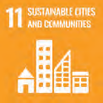

Areas of focus
We are developing our environmental objectives and ways to measure areas of focus for Climate Change and Ecology. For more details, see our Impact Report 2022.
Area of focus | Our ESG objective | Impact thesis | How we measure
Sustainable new homes  7. Affordable and clean energy  11. Sustainable cities and communities. | Integrate ESG into our new developments | By integrating energy efficiency measures into new developments and targeting a minimum 7-star rating under the Nationwide House Energy Rating Scheme (NatHERS) we will minimise energy bills for customers and increase thermal comfort through enhanced building performance | - Rating of new buildings  - Energy efficient design
Secure housing  1. No poverty  10. Reduced inequalities  11. Sustainable cities and communities | Ensure our customers are housed securely | Providing social and affordable housing with subsidised rent increases the financial, physical and social security of our customers | - Social Impact framework  - Tenant Satisfaction Survey  - Savings in annualised subsidy
Safe properties  1. No poverty  11. Sustainable cities and communities | Ensure our properties are safe | If we inspect, assess and maintain our properties to ensure they are safe and meeting standards then we are contributing to customers’ health and safety | - Property condition  - Safe and Sustainable Homes standard  - Essential Fire Safety Measure inspections  - Annual Fire Safety Statements
Customer voice  1. No poverty  10. Reduced inequalities | Ensure our customers are satisfied | Listening to customers improves our service delivery and prioritises customer experience | - Customer Feedback (Complaints and Appeals)  - Service Outcomes and Improvement  - Social Impact framework  - Tenant Satisfaction Survey
Supporting customers  1. No poverty  11. Sustainable cities and communities | Ensure our customers are supported financially, mentally, physically, and socially | Facilitating access to appropriate supports enables our customers to improve their quality of life and health and wellbeing outcomes | - Social Impact framework Program level evaluation  - Tenant Satisfaction Survey
Connected communities  11. Sustainable cities and communities | Place-making approach | Local, responsive and collaborative place plans that foster community ownership, pride and relationship building | - Place-making surveys  - Program level evaluation
Operational excellence  10. Reduced inequalities  11. Sustainable cities and communities | Ensuring alignment with codes and standards | Replace with systems and processes that support knowledge sharing and insights | - Tier 1 status
Diverse board  10. Reduced inequalities | Maintaining a capable and diverse Board | Directors with an appropriate mix and balance of skills, expertise, experience, diversity and independence effectively govern the organisation for the benefit of the customers and communities we serve | - Maintain 40:40:20 gender mix  - Skills matrix
Great people  10. Reduced inequalities | Sustain an engaged workforce | An engaged workforce, supported by our values, vital behaviours and culture, enables us to attract and retain great people to deliver high quality services for our customers | - Gallup Q12 Employee Engagement  - Retention rate
Supply chain management  8. Decent work and economic growth  10. Reduced inequalities | Upholding sound risk management in our supply chain | In continuing to build a framework that assists us to adapt and progress our capabilities to identify, assess and address risks under the Modern Slavery Act 2018 (Cth), we will improve risk management and reduce harm | - Modern Slavery Statement

<pp>38


Stakeholders
NSW Government
NSW Department of Communities and Justice
Consultants
Suppliers
Communities where we operate
Peak bodies
Media
Staff
Building and maintenance contractors
Applicants
Financiers
Customers
Community partners
Support providers
Investors
Directors
Development partners
People seeking assistance and advice for housing needs
NSW Land and Housing Corporation
NSW
Treasury
NSW Department of Planning and Environment
Federal Government
Local Councils
Drawing on the knowledge, experiences and perspectives of our customers and other stakeholders enables SGCH to navigate the increasingly complex and interconnected issues that influence the wellbeing of the communities and the natural environment in which we operate.
To successfully achieve strong outcomes for the people and communities we serve, we strive to be an organisation that listens, understands and communicates. Our customers are our largest group of stakeholders and where we have the most opportunity to create impact.
We recognise SGCH needs the support and expertise of others to be effective and achieve all aspects of our strategic plan. We seek to identify, build, develop and maintain relationships with stakeholders that contribute to achieving our goals and create shared value.
"I would not have been able to afford a safe place to live on my own. My health situation has been difficult in the last months, and it would have been so much worse if not for the safety, accessibility and excellent condition of my home… safe and stable housing has given me hope for the future and pride in myself and my home."
— Tenant Satisfaction Survey 2022
<pp>39
[The following onion-layer graph has been converted to a list, which reads from the centre out:]
- [blue] Centre
  - Customers
- [pink] Layer 1
  - Communities where we operate
  - Staff
  - Community partners
  - Directors
  - People seeking assistance and advice for housing needs
  - Support providers
  - Applicants
- [orange] Layer 2
  - NSW Department of Communities and Justice
  - Suppliers
  - Financiers
  - Development partners
  - NSW Treasury
  - NSW Department and Environment
  - NSW Land and Housing Corporation
  - Investors
  - Building and Maintenance contractors
  - Consultants
- [green] Outer Layer
  - NSW Government
  - Media
  - Local Councils
  - Federal Government
  - Peak bodies
<pp>40

Materiality assessment

Background
Following the publication of our Impact Report 2022, Our Environmental, Social and Governance Approach, we invited stakeholders to let us know the issues of importance to them to help shape our understanding, priorities and future reporting. This was conducted through a materiality assessment, shared online via our social media channels, newsletter, website and by email over a period of June to September 2022.

Assessment
In total, 20 individuals responded, including customers, team members, investors and community sector colleagues, among others. Given the small sample size, the survey data is not intended to be representative of each of these groups and should be considered indicative only.
Stakeholders were asked to prioritise the importance of specific issues and broader themes through two ranking questions.
First, they were asked to rank a set of 16 specific issues, identified through consideration of metrics within the UK Sustainability Reporting Standard for Social Housing, SGCH’s existing ESG commitments, and other governance considerations.
There were differences in priorities of different stakeholder groups, however, on average, the top two issues were:
- SGCH customers are supported (financial, health, wellbeing, social)
- Social outcomes (understanding how SGCH is contributing to change in customers lives)
These two issues were consistently in the top five across all stakeholder groups, demonstrating broad agreement that a top priority for SGCH should be to ensure social outcomes for our customers.
The next most important issues were:
- Human capital and diversity (how staff are supported and engaged, diversity and inclusion)
- Transparent information (both positive and negative, intended and unintended outcomes are reported)
- Energy efficiency (lowering costs for customers, lowering usage for our offices)
Strong caution should be taken in interpreting differences between groups due to the small sample sizes, however, one of the most notable differences was the high priority given to ‘carbon footprint’ and ‘climate change’ by the small number of investors (two) who responded to the survey, in contrast to other stakeholder groups. The SGCH Materiality Assessment Priority Matrix maps stakeholder priorities and organisational priorities.
Stakeholders were also asked to rank a set of 12 broader themes from the UK Sustainability Reporting Standard for Social Housing with the additional theme of human capital and diversity included.
Again, there were differences in priorities of different stakeholder groups. However, all stakeholder groups agreed that the top priority was:
- Affordability and security
Following that, on average, the top themes were:
- Building safety and quality
- Resident support
- Resident voice
- Staff wellbeing

Considerations for future materiality assessments
Given the small survey sample size and the complexity of the issues being discussed, for future assessments, consideration could be given to:
- Consulting with stakeholders using a broader range of methods, targeted specifically by stakeholder group
- Reviewing existing evidence, such as external data and publications.
We consider all of these issues as vital and interconnected for the sustainable development of planet, people and achieving our purpose. Prioritising areas in a considered manner allows us to focus finite resources and our efforts to continuously improve.
<pp>41

Materiality assessment priority matrix
[The following graph presents the Shareholder policy (y-axis) as a function of the Organisation policy (x-axis). Both axes range from low to high. Presented on the graph are a series of priorities placed according to these two parameters. These data have been tabulated below. The organisational policy has been split into four discrete values of LOW, MEDIUM-LOW, MEDIUM-HIGH and HIGH. The priorities, reading from top to bottom, and hence from HIGH to LOW "Shareholder policy", can be tabulated here:]
Key:
- Green: Environment
- Pink: Social
- Orange: Governance
Priority |  | Organisational Priority | Shareholder Priority
SGCH customers are supported | Pink | HIGH | HIGH
Social outcomes | Pink | HIGH
Human capital diversity | Orange | HIGH
Transparent information | Orange | MEDIUM-HIGH
Energy efficiency | Green | MEDIUM-HIGH
Resilient design of building | Green | MEDIUM-HIGH
First Nations people | Pink | MEDIUM-HIGH
Corporate governance | Orange | HIGH
Financial performance | Orange | HIGH
Carbon footprint | Green | MEDIUM-LOW
Climate Change | Green | MEDIUM-LOW
Supply chain management | Green | MEDIUM-LOW
Resource management | Orange | MEDIUM-LOW
Data privacy and security | Orange | MEDIUM-HIGH
Executive pay ratio | Orange | MEDIUM-LOW
Net zero | Green | MEDIUM-LOW | LOW
<pp>42
Shareholder priorityHigh


Tracey’s story
Tracey’s journey is one of incredible resilience and strength. From being homeless to surviving domestic violence and being in custody, the 53-year-old has had more than her share of obstacles to overcome.
“I was living in my car for nine months. It was tough but I had the help of the Salvation Army. They allowed me to have showers at their Rockdale service. I would go to my friend’s house and sit there all night but could never sleep. I lived off sandwiches and meat pies from 7-Eleven,” said Tracey, who had no place to call home from November 2015 to August 2016.
She found accommodation through a program for homeless people and moved into the rental property with her partner. He was, however, physically abusive.
“I was in a domestic violence situation for seven years. My ex-partner had a fall from a building where he was working and sustained a traumatic brain injury. I was warned he would again become violent, but I still cared for him. One night, he harmed me so badly and I called the police to remove him.”
Tracey was also using drugs at that time and had to enroll in a court mandated rehabilitation centre. But when she received an eviction letter asking her to leave her rental property due to unpaid rent, she left rehabilitation.
“I was never behind in my rent. My rent was always paid even though I was using. But I was charged for his rent six months after he had gone. I received an eviction notice saying I owed them thousands of dollars. I was so upset that I left rehab,” said Tracey, adding that leaving the compulsory drug program mid-way led to her being in custody.
After she was released from custody, Tracey began her journey of turning her life around. She engaged with a support network that included a doctor, a social worker, alcohol and drug recovery support network, victim services and her family.
She began studying for a Certificate IV in Community Services in February 2021 and as an SGCH customer since 2016, was referred to our Catalyst program for financial support. Tracey successfully completed her course and credits SGCH’s Housing Plus Manager Carrie with helping prepare her for the workforce.
“My Certificate IV last year wasn’t doing work placement due to COVID, so Carrie gave me a list of places to do volunteer work. I had worked in government jobs before, was a marriage celebrant and a Justice of the Peace for 25 years but I hadn’t worked for 12 years due to what I had gone through. She helped me update my resume and word it in a way to highlight my work as well as my lived experience. She would do mock interviews with me,” said Tracey, adding, “The support and encouragement I received from Carrie is something I am extremely grateful for.”
Tracey’s hard work and determination paid off, and she was offered a job in April 2022 in the Women’s Justice Network– a not-for-profit organisation that mentors and advocates for women and female youth who have been affected by the criminal justice system. She supports women who were incarcerated to resettle into the community–a job she loves and is passionate about because of her lived experience. Her contract was extended in July because of her strong work performance.
Tracey still has triggers and is undergoing counselling. She is also struggling with PTSD and anxiety, after years of facing domestic violence. She has also had knee replacement surgery.
“A lot has happened, but I am still going strong. I really love the people I work for and the women I work with. I am giving back to a place where I came from. My Wednesdays, Thursdays and Fridays are the best days of my week.”
<pp>43
"A lot has happened, but I am still going strong. I really love the people I work for and the women I work with. I am giving back to a place where I came from."
Tracey
<pp>44
- 01 Overview
- 02 Approach

03 Performance
- 04 Financial report
<pp>45
Cartoon image omitted
<pp>46

Customers
SGCH manages the largest portfolio of community housing tenancies in Sydney. Our portfolio comprises a mix of social housing, Aboriginal social housing, transitional housing, affordable housing and Specialist Disability Accommodation.
We are a recognised industry leader in tenancy management, with a practice that places tenant outcomes at the centre of our work.
We work with a range of partners to deliver services and programs in collaboration with, or on behalf of, the NSW Government including the Social and Affordable Housing Fund, and the Social Housing Management Transfer, Port Jackson Supported Housing, and Together Home programs.
Together, we support SGCH customers to sustain their tenancies and connect to the services and supports they need. In addition to tenancy management services, our team supports our customers with a range of services detailed in the chart below.
[blue] Support Coordination
Connecting customers to services including financial services, health, mental health, homelessness, domestic and family violence, drug and alcohol dependence, youth and aged care and disability services.
[green] Housing Plus Services
Including training, education, and employment assistance through our Catalyst Program, Strive Scholarships, no-interest loans and DigiConnect program.
[pink] Placemaking
Offering local activities and events that promote social connection and engagement. We support tenant groups and partner with a range of local organisations to deliver programs and services that meet customer needs and interests.
<pp>47

Increasing housing options for Aboriginal people
SGCH has been delivering on our commitment to increase Aboriginal access to mainstream community housing and sustaining Aboriginal tenancies through our Community Housing for Aboriginal People (CHAP) program. Key achievements of this program include increased allocations, cultural competency, partnership networks and a Statement of Commitment to Aboriginal People.
At our Gibbons Street, Redfern development we exceeded our commitment of providing 25% of homes to Aboriginal people, achieving 40%.
This provided the opportunity for a number of Aboriginal people to return to Redfern to live closer to their family and community in affordable housing, including Dixie (see page 14).
Our Aboriginal Affordable Housing Engagement Coordinator role, funded in partnership with the City of Sydney, works closely with the community to increase the number of Aboriginal affordable housing tenancies within the city.
In 2021 we implemented a single common Register of Interest for Affordable Housing in the City of Sydney form to streamline effort. Developed and managed by SGCH, people register their details in one simple form and are matched with the community housing provider (including Bridge Housing and City West Housing) who best meets their affordable housing needs.
The City of Sydney has since provided additional funding for the role to extend for 24 months until 2024, and expanded support to include an Aboriginal Support and Partnerships Coordinator role to improve the organisation’s cultural skills and customer service for Aboriginal customers.
<pp>48-49

Customers snapshot FY21/22
2,029
Children
88%
Of social housing allocations to priority target groups
1,362
People in affordable
housing

We are committed to delivering flexible, customer-centric services that are relevant, meaningful, and responsive to needs.
55
Languages spoken other than English;
Arabic, Chinese and Vietnamese most common
11,437
Customers
- 11,437 Customers
- 55 Languages spoken other than English; Arabic, Chinese and Vietnamese most common.
- 79% Overall satisfaction
- 2,029 Children
- 4,083 Single person households
- 1,362 People in affordable housing
- 10,075 People in social housing
- 88% Of social housing allocations to priority target groups.
- 98% Of tenancies sustained <2% eviction rate.
- 22 Days turnaround time for vacancies (5.87 days below benchmark)
- 839 Aboriginal and/or Torres Strait Islander households.
<pp>50

Supporting our customers
We have dedicated Support Coordinators to help vulnerable tenants access wraparound support services.
They identify and build relationships with customers and, using a person first approach, break down barriers to access services and support. We partner with specialist services to connect our customers to the support they need.

Reasons for referral
[The following pie-chart has been converted to a list, reading clockwise from right (largest):]
- Arrears and debt: 44
- Financial difficulty: 20
- Mental Health:43
- Medical: 11
- Elderly/frail: 6
- Disability: 4
- Addiction: 1
- Property care: 18
- Domestic Violence: 10
- Noise and Nuisance: 5
- Risk of self-harm: 2
- Youth: 2
- Social isolation: 3
- Other: 5
<pp>51

Together Home
We are a participant in the Together Home program providing 80 tenancies for people who had been sleeping rough. Participants are linked with wraparound support services provided by the Newtown Neighbourhood Centre, the Salvation Army and St Vincent de Paul.
In May 2022, we were awarded a $2.75m grant from the Department of Communities and Justice Together Home Transition Program to increase the supply of social housing; SGCH is co-contributing funds to acquire a unit complex with 10 homes to support Together Home program participants.
"Before SGCH, I had been homeless, lived in transitional housing and was experiencing complete instability in my life. I have been a tenant with SGCH and lived in my current apartment for 8 years and 6 months. This is the longest I have lived at any one address ever, for this I am extremely grateful to SGCH and would like to say thank you."
— Tenant Satisfaction Survey 2022

Key findings

Support coordination
- 916 Customers supported
- 527 New referrals
- 389 Carried over from FY20/21
- 173 Engaged with external support services
- 60 On a waiting list for support services
- 25% Previously referred
<pp>52

Port Jackson
Port Jackson Supported Housing Program (PJSHP) is managed by SGCH to provide transitional housing tenancies for people who require a high level of support to stabilise their lives and develop the skills needed to maintain longer-term tenancies when they exit the program. We partner with 19 specialist services who deliver support to 214 households in the program across five Local Government Areas (LGAs).
"I have always been drawn to roles which allow me to make a positive impact on the lives of others. SGCH itself and the Place Coordinator role align closely with my values. I love being out and about working in our communities and connecting with our customers. I learn so much from having conversations and participating in activities with our residents.
— Megan, Place Coordinator
<pp>53

Shirley’s story
*Shirley had been in and out of temporary accommodation for long periods of her life. The 25-year-old was homeless and had also been an inpatient several times at St Vincent’s mental health unit.
*]Name changed for privacy
After Shirley was referred to PJSHP, she was finally able to settle in a home that she could call her own. She sought YWCA’s assistance to get some furniture and advance rental amount. The stability of PJSHP meant she could access a network of services and focus on her mental health.
Once she was able to find her feet, Shirley reconnected with her family and visited them in Brisbane over Christmas. They offered her permanent long-term housing, during her visit. After her successful tenancy in Port Jackson, she felt confident and ready to move in with them.
Her transition back to a family home in Queensland has been a positive outcome for a woman who had a traumatic history. Shirley was among 33 women and 83 customers in 2021 who were assisted to transition into independent living.
<pp>54

Housing Plus

Catalyst
Our catalyst program supports customers to meet their training and employment goals with personalised coaching and funding.

Strive Scholarships
Strive Scholarships provide money for educational and extra-curricular costs based on the student's level of study.

Key findings

Catalyst
- 171 Customers supported
- 38 Started paid employment
- 13 In accredited training
- 3 in both paid employment and accredited training

Key findings

Strive Scholarships
- 267 Customers supported
- $296,500 Total scholarships awarded
- 70 Primary students each awarded $500 Kindergarten —Year 6
- 95 Secondary students awarded $1,000 Year 7—Year 12
- 111 Tertiary scholarships awarded. $1,500 each
<pp>55

Paul’s story
Thirty-two-year-old *Paul was struggling financially after his employment took a hit with COVID. Though he had a good employment history and had previously had success finding work, Paul unexpectedly found himself in arrears and in between jobs.
*]Name changed for privacy
“I was a carpenter last year this time, but it was hard bouncing back after COVID,” he said.
During the Christmas and New Year holiday period, Paul, who lives in our affordable housing at City Road Chippendale, was not given any work hours and fell further behind in his rent payments.
“I worked for one of the biggest construction companies in Sydney and they went broke and owed me a lot of money. It was tough so I reached out to Carrie and she basically told me what support they can provide,” he said.
Carrie Yang is our Housing Plus Manager and she worked with Paul to support him to sustain his tenancy and referred him to Catalyst, our employment and training program.
Paul then decided to make a career switch and become a garbage truck driver because of the stability the job promised. “I thought waste is something that always needs to be picked up and I know there would always be work. I enjoy driving too.”
He then worked towards his goal of obtaining a Medium Rigid (MR) licence for interstate truck driving. He was referred to a Cert III Driving Operations course. With his skills, persistence and our support, Paul landed himself a full-time contract as a garbage truck driver. He used Catalyst funds to purchase work boots and clothes as well as fuel cards.
“Since I began driving, I have never looked back. I love driving.”
Now, Paul is planning to move to a two-bedroom house in Western Sydney because his income exceeds the affordable housing threshold and wants a bigger property for him and his son.
Carrie Yang is our Housing Plus Manager and she worked with Paul to support him to sustain his tenancy and referred him to Catalyst, our employment and training program.
<pp>56

Arthur’s story
Arthur, 51, has been a single father to his sons Arthur Jr, 17, and Thomas, 15, for almost a decade. It was when their mother was diagnosed with cancer that Arthur decided to step up so he could take care of their boys, then seven and five years old.
“I was in and out of jail and was abusing drugs,” said Arthur, who is a Wiradjuri person. “When their mum was very sick and in her last stages of cancer, I knew I had the opportunity to get clean. I did everything what the courts wanted me to do. I went to rehab and I did several parenting programs. I knew if I didn’t step up and if I didn’t do the right thing, they would be placed in foster care until they turned 18.”
It took him two years to get custody of his children and he moved to Bonnyrigg, where he had grown up. “I moved back into my mum’s house when I got custody of my children. It was tough as I had to explain to them what happened to their mum and had to take them to her funeral. I had to be both a mother and a father to them.”
Now teenagers, Arthur Jr and Thomas received Strive scholarships in October 2021 and were also referred to the Catalyst program.
“We were able to buy school shirts, shorts and shoes. I am so glad I didn’t have to buy them cheap shoes but a decent pair that will last them,” said the father.
The boys are also doing several vocational courses while studying. Through Catalyst, Arthur Jr is pursuing courses in construction and hospitality at school.
“The courses are building their confidence. They are not hanging around the street and with their friends but are doing something for themselves and getting skills that they wouldn’t have been able to get otherwise.”
Both boys are working part time in fast food restaurants, with Arthur Jr learning to drive and aspiring to work as a tradesperson in the future.
Once Arthur Jr gets his licence, he will receive some professional driving lessons free of charge under our partner Uniting’s Driver Licensing Access program, and will be matched to a trained volunteer who will use their own vehicle to help complete his compulsory driver logbook hours.
“With a car, he can go places to work. He is trying to save money for a car,” said the proud father.
"The courses are building their confidence. They are not hanging around the street and with their friends but are doing something for themselves and getting skills that they wouldn’t have been able to get otherwise."
– Arthur
<pp>57
Image omitted.
<pp>58

Place-based approaches
We focus on connecting customers to a range of localised training and educational workshops and social, health and wellbeing activities and events.
The Community Greening program was started in 2000 by the Royal Botanic Garden (RBG) Sydney to facilitate community-led gardens in social housing estates across NSW. Sponsored by the Department of Communities and Justice (DCJ), the program aims to empower vulnerable communities while providing a broad range of health, training, economic and social benefits.
We have partnered with Community Greening across suitable sites for over six years to foster community connections for customers and promote food security.
<pp>59
[Image captions]
1. Julie enjoying herself at the gardening workshop in her community in Barton Road, Artarmon
18
2. SGCH has partnered with the Royal Botanic Garden to run the Community greening program across our sites

Key findings

Place coordination
- 9 Regular sites host community garden workshops
- 18 Local tenant groups
- $109,842 In community grants
<pp>60

Soheyla, Liverpool
“I never used to garden until SGCH installed the garden beds,” said Soheyla Ramezani, who attends SGCH’s gardening workshops regularly.
“I love being able to give my family and friends what I grow in the garden. I enjoy the workshops so much that I skip my English classes to attend these workshops,” added Soheyla, who has been in Sydney for almost three years.
"I love being able to give my family and friends what I grow in the garden. I enjoy the workshops so much that I skip my English classes to attend these workshops."
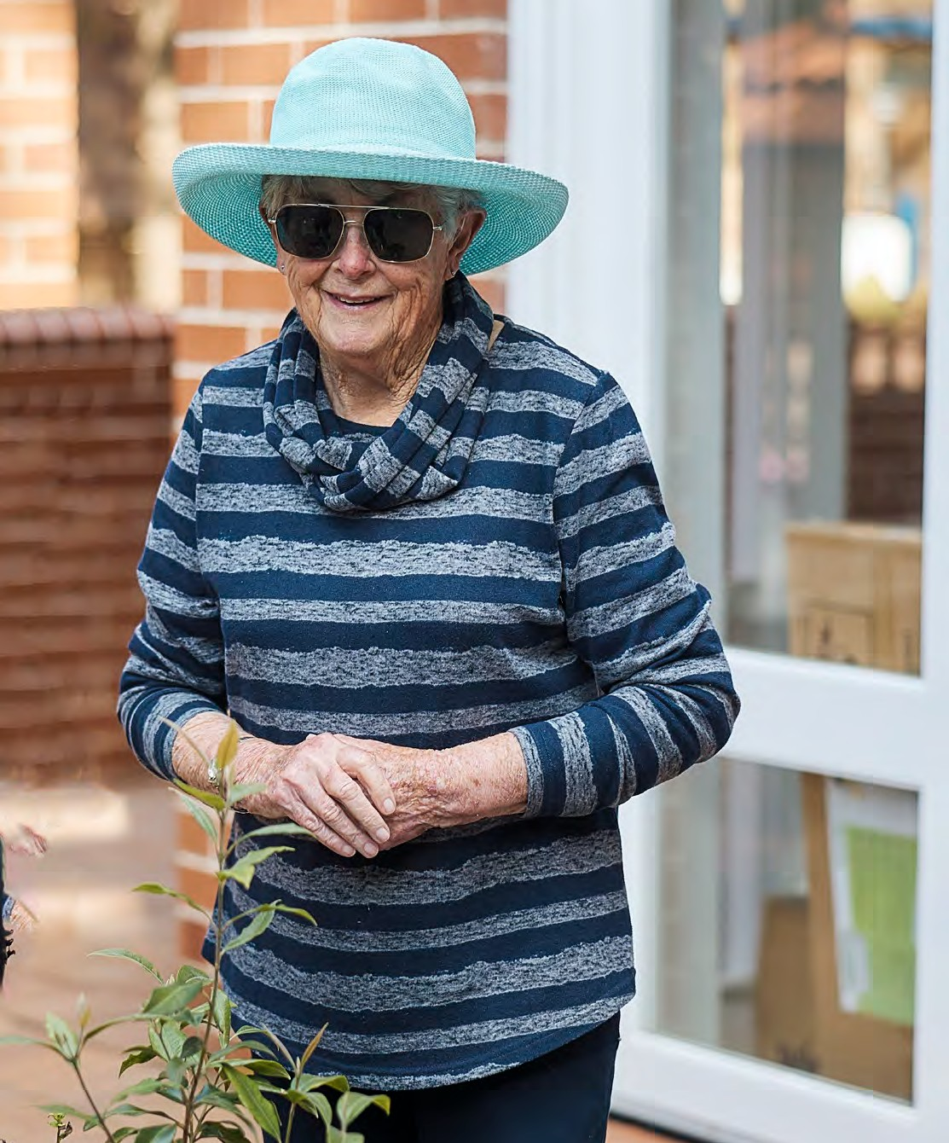
Soheyla
2
[Image captions:]
1. Customers discover the joy of gardening and learn to grow their own veggies and fruits at SGCH's community greening workshops run by RBG and sponsored by DCJ
2. Ailsa at the gardening workshop in Cammeray
<pp>61

Ailsa, Cammeray
Since 2019, SGCH has partnered with Community Greening to host quarterly gardening workshops in Cammeray. Ailsa, a Cammeray resident, has attended all workshops since they began. She sees it as an opportunity to garden with others, often creating community garden pots. She loves seeing the results as the plants bloom and beautify the common spaces.
"I was always a gardener. When I was teaching children with disabilities in the 1990s, some of us teachers went on a course on gardening, and that developed my interest. I am having trouble with my back currently, but I hope to be back to my pots in time for spring."
— Ailsa
<pp>62

Customer profiles
[These pie-charts have been made into lists here, from top, clockwise:]
10,075 Social Housing
- 2,220 Households with a head tenant or household member with a disability
- 3,710 Single households
- 2,437 Single households (aged +55)
- 1,744 Children in all households
- 196 Customers exiting SGCH to private rental/home ownership/friends and family.
- $523.37 Average household weekly income
- $267.67 Average weekly rent
- 696 Households identifying as Aboriginal and/or Torres Strait Islander
- 1,029 Customers receiving support
- 6,175 Head tenants
<pp>63
1,362 Affordable housing
- 57 Households with a head tenant or household member with a disability
- 373 Single households
- 78 Single households (aged +55)
- 285 Children in all households
- 100 Customers exiting SGCH to private rental/home ownerships/friends and family
- $832.04 Average household weekly income
- $341.87 Average weekly rent
- 143 Households identifying as Aboriginal and/or or Torres Strait Islander
- 23 Customers receiving support
- 789 Head tenants
<pp>64

Social Impact
SGCH is committed to measuring and managing the impact of its work and the value we create for customers and stakeholders.
For SGCH, our social impact is all the outcomes for people, communities and places resulting from our work, including:
- short and long term outcomes
- positive and negative outcomes
- direct and indirect outcomes
- intended and unintended outcomes.
We have had in place various strategies and tools to measure our impact since 2014. With an ongoing focus on continuous improvement, we reviewed our existing framework in 2021 with consultants, Think Impact, to develop a renewed narrative on the change we create–our Theory of Change. Additionally, we streamlined indicators and measures with emphasis on providing greater clarity for our team, customers, partners and stakeholders.
Consulting broadly across the organisation and the Tenant Coordination Panel, SGCH has produced it’s updated Social Impact Framework – this is the ‘S’ in our ESG commitment.
[The following vertical flowchart, reading from left to right, has been converted to a list:]
Collaboration and partnership
- Housing Supply AND
- Housing Management
Feeds into
- Home
  - Customers have sustainable, stable and affordable housing that is in good condition and meets their needs.
- Safety
  - Customers feel safe at home and in their neighbourhoods.
Feeds into
- Opportunity to improve lives and build communities (which is feed by:)
  - Support coordination
  - Community development & place-based approaches
  - Collaboration and partnerships
(end Collaboration and Partnership)
Feeds into
- Health
  - Customers have improved health and wellbeing
- Community
  - Customers feel satisfied with and connected to their community
- Economy
  - Customers have reduced financial stress
- Education
  - Customers have access to appropriate education and training
- Empowerment
  - Customer have knowledge of their rights, are empowered to make decisions and feel respected and heard
<pp>65
SGCH’s Social Impact Framework guides our approach across four interconnected areas of work:
- Defining impact: ensuring we are clear about our intended impact
- Measuring impact: ensuring we measure what matters
- Managing impact: embedding an impact-focused culture and systems
- Communicating impact: ensuring accountability to our key stakeholders.
The framework includes our Theory of Change and our Core Social Outcomes, which guide all aspects of our approach to social impact, including our Strategic Plan and our ESG Approach and reporting. The framework also guides how we measure our core outcomes by setting out indicators, measures, and agreed principles. It is aligned to the NSW Human Services Outcomes Framework, to evidence changes across a core set of domains in Home, Safety, Health, Social & Community, Economic, Education and Skills and Empowerment.
<pp>66

Customer insights

Tenant Satisfaction Survey 2022
Each year all households managed by SGCH are invited to participate in a survey to tell us about their satisfaction and experience with SGCH over the past year. This helps us learn and improve what we do and deliver better outcomes for people and communities.
Our 2022 survey was run between 30 May and 1 July. In total, 1,846 customers took part, which represents a response rate of 26%.
The survey was run by Community Housing Industry Association (CHIA) NSW. The core questions used in the survey were developed through consultation between CHIA NSW and the community housing sector and were informed by Housemark’s best practice customer satisfaction framework for the UK social housing sector, as well as guidelines laid out by the National Regulatory System for Community Housing. Many of the questions are asked across multiple community housing providers, which enables CHIA NSW to provide a benchmark for comparison to other organisations and to drive improvements through mutual learning.

In addition to the core questions, this year SGCH added a number of outcome measures to the survey to begin measuring the social outcomes defined through our Social Impact Framework. This included the reintroduction of the Personal Wellbeing Index (PWI), which is a score developed by Deakin University¹ to measure subjective wellbeing. The PWI contains seven items, each one corresponding to a quality of life domain: standard of living, health, achieving in life, relationships, safety, community-connectedness, and future security. Scores can range from 0 to 100, with higher scores reflecting greater satisfaction with life.
Domain | Key findings | Customer quotes
Home | - 80% are proud of their home (baseline)  - 79% agree their home is suitable to their circumstances (baseline)  - 74% are satisfied with the condition of  their home (up 3% from 2021) | “Before SGCH, I had been homeless, lived in transitional housing and was experiencing complete instability in my life… this is the longest I have lived at any one address ever.”
Safety | - 80% feel safe and secure in their home (baseline)  - PWI safety score = 69.2 (baseline) | “I feel safe and settled in my home and importantly, I feel safe being out in the community, you have made such a big difference to my life.”
Health | - 72% agree life has improved since living at a SGCH property (up 5% from 2021)  - PWI overall score = 63.4 (baseline)  - PWI health score = 59.2 (baseline) | “My mental health has improved since becoming a SGCH tenant, I can now feel secure in my future regarding my living situation.”  “My health situation has been difficult in the last months, and it would have been so much worse if not for the safety, accessibility and excellent condition of my home.”
Community | - 77% are satisfied with their neighbourhood as a place to live (up 2% from 2021)  - PWI community score = 61.0 (baseline) | “I have made good friends with most of my neighbours where we visit each other's homes and have coffee, dinner and watch Netflix...”  “I love my beautiful home, and the great community I now  live in.”
Economy | - 70% agree they can afford most of the things they need (baseline)  - PWI future security score = 62.9 (baseline) | “I feel very comfortable and happy not having to worry about how I can pay my bills.”  “I myself am a single parent to three young girls… rent prices are good and affordable which makes life easier for me to be able to have some $ to do things with my daughters.”
Education and skills | — No measures included in Tenants Satisfaction Survey –will be measured in program-specific surveys. | “SGCH have completely changed my life since being in affordable housing. It allowed me to complete a University degree and achieve my dreams, I will always be grateful for that.”  “SGCH have been amazing support, they helped me in my darkest moments. If it wasn’t for them I don’t know where I would be, having the comfort of affording the rental property I have been provided in this day and age has opened the doors for me to be able to continue my studies and try to open my own business in the future.”
Empowerment | - 82% agree since having stable housing they can focus on the future and things that are important to them (baseline)  - 67% are satisfied that SGCH listens to tenants' views and acts on them (up 7% from 2021) | “Safe and stable housing has given me hope for the future and pride in myself and my home.”  “I am forever thankful to SGCH for providing stable housing so I can focus on other matters in life without the stress of share homes, and high market rental prices.”

^{1.}] International Wellbeing Group (2013). Personal Wellbeing Index: 5th Edition. Melbourne: Australian Centre on Quality of Life, Deakin University. http://www.acqol.com.au/instruments#measures

The survey provided promising baseline data that will allow us to monitor changes over time.
<pp>67
Domain | Key findings | Customer quotes
Home | - 80% are proud of their home (baseline)  - 79% agree their home is suitable to their circumstances (baseline)  - 74% are satisfied with the condition of their home (up 3% from 2021) | "Before SGCH, I had been homeless, lived in transitional housing and was experiencing complete instability in my life... this is the longest I have lived at any one address ever."
Safety | - 80% feel safe and secure in their home (baseline)  - PWI safety score = 69.2 (baseline) | "I feel safe and settled in my home and importantly, I feel safe being out in the community, you have made such a big difference to my life."
Health | - 72% agree life has improved since living at a SGCH property (up 5% from 2021)  - PWI overall score = 63.4 (baseline)  - PWI health score = 59.2 (baseline) | "My mental health has improved since becoming a SGCH tenant, I can now feel secure in my future regarding my living situation."  "My health situation has been difficult in the last months, and it would have been so much worse if not for the safety, accessibility and excellent condition of my home."
Commun-ity | - 77% are satisfied with their neighbourhood as a place to live (up 2% from 2021)  - PWI community score = 61.0 (baseline) | "I have made good friends with most of my neighbours where we visit each other's homes and have coffee, dinner and watch Netflix..."  "I love my beautiful home, and the great community I now live in."
Economy | - 70% agree they can afford most of the things they need (baseline)  - PWI future security score = 62.9 (baseline) | "I feel very comfortable and happy not having to worry about how I can pay my bills."  "I myself am a single parent to three young girls... rent prices are good and affordable which makes life easier for me to be able to have some $ to do things with my daughters."
Education and skills | - No measures included in Tenants Satisfaction Survey-will be measured in program-specific surveys. | "SGCH have completely changed my life since being in affordable housing. It allowed me to complete a University degree and achieve my dreams, I will always be grateful for that."  "SGCH have been amazing support, they helped me in my darkest moments. If it wasn't for them I don't know where I would be, having the comfort of affording the rental property I have been provided in this day and age has opened the doors for me to be able to continue my studies and try to open my own business in the future."
Empowerment | - 82% agree since having stable housing they can focus on the future and things that are important to them (baseline)  - 67% are satisfied that SGCH listens to tenants' views and acts on them (up 7% from 2021) | "Safe and stable housing has given me hope for the future and pride in myself and my home."  "I am forever thankful to SGCH for providing stable housing so I can focus on other matters in life without the stress of share homes, and high market rental prices."
<pp>68

Continuous improvement
Each year, the insights provided by our customers through the Tenant Satisfaction Survey provide an opportunity to understand what we are doing well and where we need to improve.
In 2021, our Service Outcomes and Improvement team analysed the survey results to identify key findings and proposed actions to improve and increase our customer service and satisfaction. They worked with colleagues in the Customers division to identify issues and positive areas of practice to replicate. For example, there were variations between our regions which when the survey was conducted, reflected three areas across Sydney. In particular, results from our Northern Sydney region where 1,400 tenancies transferred to SGCH in 2019 under the Social Housing Management Transfer (SHMT) program were lower than the rest of the portfolio. This trend has been consistent with the other SHMT providers across the state.
Coming together as a team to understand how different regions delivered services helped with cross- skilling our people and improving understanding of customer needs, which has led to some pleasing improvements in the latest survey (TSS 2022).
In 2021 we found | What we did | And in 2022 our results were
Overall satisfaction. This  75% is not at the level that we  aspire to achieve. In  particular, the SHMT Program in Northern Sydney was low compared to the rest of our portfolio. | Gathered our Sustainable Tenancies, Income Management, Placemaking and Housing Pathways teams from all regions to workshop best practice  service delivery with specific reference to the issues identified by the Tenant Satisfaction Survey 2021 results. | (up 4%*)  79% In Northern Sydney  we saw a 10%* increase
Overall satisfaction with  73% our tenancy management services. The survey  revealed significant differences between regions ranging from 60% in Northern Sydney to 79% in Western Sydney. | Put a Community of Practice model in place to share tenancy management best practice between Sustainable Tenancies, Income Management, Placemaking and Housing  Pathways teams with a focus on  continuous improvement. | (up 1%)  74% In Northern Sydney  we saw a 6%* increase
Satisfaction with SGCH  60% listening to tenants’ views and acting on them. There  was a wide variation between regions. | Place Coordinators have changed from being centrally managed to being embedded in regions, delivering targeted improvement plans for identified blocks. | (up 7%*)  67% In Northern Sydney  we saw a 9%* increase
Satisfaction with how easy  62% it is to get answers,  information and help  from SGCH. | Customer Care Hub launched on 1 July 2021 with a central team who aim to provide first-resolution responses to customer enquiries. | (up 5%*)  67%
Overall satisfaction with  67% repairs and maintenance services. Our lowest  satisfaction levels were in Northern Sydney where the contract was not managed by SGCH. | On 1 July, repairs and maintenance services for Northern Sydney transferred from LAHC’s contractor to SGCH’s multi-trade contractor. | (up 1%)  68% In Northern Sydney  we saw a 11%* increase

"SGCH are an amazing support to low/ moderate income earners. I myself am a single parent to three young girls and being able to rent with you has been a saving grace over the past few years. I've felt secure and content renting from you and feel lucky enough to be able to. Always answering questions that I may have, repairs are done within reasonable times and rent prices are good and affordable, which makes life easier for me to be able to have some $ to do things with my daughters. Thank you!"
— Tenant Satisfaction Survey 2022
<pp>69
In 2021 we found | What we did | And in 2022 our results were
75%  Overall satisfaction. This is not at the level that we aspire to achieve. In particular, the SHMT Program in Northern Sydney was low compared to the rest of our portfolio. | Gathered our Sustainable Tenancies, Income Management, Placemaking and Housing Pathways teams from all regions to workshop best practice service delivery with specific reference to the issues identified by the Tenant Satisfaction Survey 2021 results. | 79%  (up 4%*)  In Northern Sydney we saw a 10%* increase
73%  Overall satisfaction with our tenancy management/services. The survey revealed significant differences between regions ranging from 60% in Northern Sydney to 79% in Western Sydney. | Put a Community of Practice model in place to share tenancy management best practice between Sustainable Tenancies, Income Management, Placemaking and Housing Pathways teams with a focus on continuous improvement. | 74%  (up 1%)  In Northern Sydney we saw a 6%* increase
60%  Satisfaction with SGCH listening to tenants' views and acting on them. There was a wide variation between regions. | Place Coordinators have changed from being centrally managed to being embedded in regions, delivering targeted improvement plans for identified blocks. | 67%  (up 7%*)  In Northern Sydney we saw a 9%* increase
62%  Satisfaction with how easy it is to get answers, information and help from SGCH. | Customer Care Hub launched on 1 July 2021 with a central team who aim to provide first-resolution responses to customer enquiries. | 67%  (up 5%*)
67%  Overall satisfaction with repairs and maintenance/services. Our lowest satisfaction levels were in Northern Sydney where the contract was not managed by SGCH. | On 1 July, repairs and maintenance services for Northern Sydney transferred from LAHC's contractor to SGCH's multi-trade contractor. | 68%  (up 1%)  In Northern Sydney we saw a 11%* increase
* Statistically significant difference
<pp>70

Safe and sustainable homes
SGCH manages a portfolio of property assets with a value of approximately $3.7 billion, including $1.3 billion total assets on our balance sheet. We invest in quality new buildings and improve the safety and sustainability of our existing portfolio.
Our homes include a mix of properties we own, and properties we manage on behalf of the NSW Land and Housing Corporation, local councils, private investors and private landlords. We have experience providing asset management services for a range of housing types from single cottages through to 18-storey high-rises.
As stewards of significant community resources, we understand our responsibility to deliver and maintain resilient, quality social and affordable homes. We proactively maintain the assets for the public benefit to meet community needs now, as well as acting to preserve the underlying asset value, over the longer term.
SGCH has well established systems and processes for planning, budgeting, and monitoring the performance of asset maintenance services for a large scale portfolio of more than 7,000 homes.
[The following pie-chart has been presented as a list:]
7,068 Total Homes
- 2,242 Owned
- 758 Leased
- 4,068 Managed
Property assets | Year 2018 | 2019 | 2020 | 2021 | 2022
Owned | 1,542 | 1,659 | 1,828 | 2,164 | 2,242
Leased | 616 | 665 | 657 | 700 | 758
Managed | 2,595 | 4,078 | 4,072 | 4,063 | 4,068
Total homes | 4,759 | 6,402 | 6,557 | 6,927 | 7,068
Social housing | 4,432 | 6,011 | 6,075 | 6,340 | 6,269
Affordable housing | 324 | 391 | 482 | 587 | 799
<pp>71

Aboriginal Housing Office transfers
Our net total social housing homes has dropped from 6,340 in 2021 to 6,269 in 2022 for a range of reasons. Thirty-eight of these social housing properties were transferred to Tharawal Housing Aboriginal Corporation under the Property Management Transfer program in July 2022. This was a goal under the ‘Family, Strong Communities’ plan where the management across the state of 1,500 Aboriginal Housing Office (AHO) properties were transferred to support the growth of Aboriginal Community Housing Providers.
An AHO Customer Exit research project sought feedback on areas for SGCH to understand and improve, with a focus on cultural competency. Overall, the 20 respondents were positive about their customer experience. We heard AHO customers appreciated being invited to cultural events.
One of the surveyed customers told us “There can be insensitivity of how you approach black fellas -there are issues with past mistrust of government and not for profit services. All people who work with people should be able to do that with a cultural lens.”
SGCH will be incorporating these authentic customer voices within a program of targeted customer facing staff coaching. We will continue to engage Aboriginal customers in this way to better match our customer service and improve our cultural insights.
Maintaining over 7,000 homes to good condition in connected locations where people can access opportunity.
<pp>72-73

Homes snapshot FY21/22
This snapshot includes key findings from our Tenant Satisfaction Survey and an overview of the activities undertaken in our Homes portfolio.
80%
Customers are proud of their home
- 80% Customers are proud of their home
- 22,496 Maintenance work orders delivered
- 68% Overall satisfaction with repairs and maintenance
- 79% Customers agree with their home is suitable to their circumstances
- $19,046,338 Spent maintaining homes
- 26,081 Work orders
- 26,419 Calls taken for customer repair requests
- 80% Customers feel safe and secure in their homes
- 74% Overall satisfaction with condition of property
- 526 Property Assessment Surveys completed
<pp>74

Maintaining homes
We focus our asset maintenance planning and investment in quality innovation to make sure our homes are fit for purpose now, and resilient into the future.
We deliver asset maintenance services to respond to customer needs. Our primary model of delivery for asset maintenance services is through two multi-trade contractors, Assett Group Services and SR Constructions. They deliver responsive and planned maintenance, and regular common area maintenance such as lawn mowing and servicing bin rooms.
Our annual capital upgrade program is data-driven, informed by our Property Assessment Surveys. We prioritise our investment by balancing performance, cost and risk. Our own Safe and Sustainable Homes (SASH) standard prioritises our approach to upgrade existing properties in a more strategic, financially and environmentally responsible way. It includes an asset standard focused on compliance with fire, safety, and Building Code of Australia (BCA) standards. Its implementation helps us lift the standard of housing to be higher or consistent with the broader social and affordable housing community, if not higher. It also incorporates NSW Land and Housing Corporation (LAHC) Asset Performance Standards, which set the operating and compliance framework for the portfolio managed on behalf of the NSW Government.

Works by maintenance category
[The following pie-chart is presented as a list:]
- Fire safety: 1,835
- Common area: 583
- Scheduled maintenance: 224
- Planned maintenance: 1,164
- End of Tenancy: 1,639
- Disability modifications: 239

Repair requests by category
[The following pie-chart is presented as a list:]
- Urgent repairs (24 hours): 5,872
- Non-urgent repairs (14 days): 12,107
- Emergency work (4 hours): 2,218
- New defect liability period: 224
<pp>75

Spotlight on Northern Sydney
Though tenancy management transferred to SGCH in 2019, until the end of financial year 2020/21, LAHC's contractor provided repairs and maintenance services for customers in our Northern Sydney properties.
Following the transfer of maintenance responsibilities on 1 July 2021, SGCH has invested in the maintenance of older properties, working closely with customers and our appointed contractors to improve customer satisfaction with repairs and maintenance. When SGCH took over the contract for managing Greenway, 25% of units had been categorised 'below maintained'. That figure has now reduced to 4%. Tenant satisfaction of maintenance has increased from 49% to 60%. We recognise there is more to do but are pleased with the improvements we've been able to provide for our customers.

Key facts

Northern Sydney
- 1,424 Homes
- 98% Units
- 60% Located over 3 sites.
<pp>76

Ljubica's Story
Ljubica, 73, has lived in the Greenway development in Kirribilli for more than 20 years. Initially in a one-bedroom apartment, she recently moved into a two-bedroom apartment with her granddaughter.
On living at Greenway, Ljubica says: “I love the community and the community centre –they are so good for us. We are close to the train station and transport and it is nice to meet outside for coffee with friends.”
When she moved into the two-bedroom apartment in December 2021, Ljubica says there was work that needed to be done to improve her home and meet her living needs. Suffering from chronic knee and hip pain and stiffness, it was clear modifications would need to be made to the very old bathroom to assist access and mobility. She applied for the bathroom to be modified, including replacing the old-fashioned bathtub with an easily accessible shower. “Joseph (tenancy manager) approved all the work. He was like part of the family, the way he understood us. I am very happy with the work.”
The old stove/oven also needed to be replaced. “The man living there before me didn’t cook so it was never used, and it was very old and non-functional. I tried to cook and bake but it didn’t work. I said to the manager, ‘Can you do something?’ He approved it and now I have a brand new oven.” Ljubica says the upgrades have made a huge difference.
“My apartment now is so beautiful and so comfortable. It’s my home and I like it.”
"I love the community and the community centre – they are so good for us. We are close to the train station and transport and it is nice to meet outside for coffee with friends."
— Ljubica
<pp>77
Image omitted
<pp>78

Teresa’s story
Teresa coordinates our Handyperson Team, which is responsible for addressing property issues, making a big difference to customer quality of life and satisfaction. Teresa and the team are working on numerous projects across our portfolio in Greater Sydney to enhance community spaces for our customers.
“My team is passionate about creating great places and thriving communities for customers. We can achieve this by small things that can have a great impact. We want to make these spaces amazing. The hardest part of my job is prioritising.”
Teresa and her team are striving to provide vibrant common spaces that encourage residents to connect. Their biggest projects this year included renovating community rooms at Penrose Street, Lane Cove and Amherst Street, Cammeray.
Everything is thought through to ensure ease of use and accessibility for customers, such as drawers in the kitchens with large handles to be opened easily. In Penrose and Amherst, big televisions have been installed along with lounges, coffee machines, zip taps and air conditioning so customers can book the space for parties and special events, as well as regular opportunities to socialise.
“Any little thing we can do to improve their lives and to create a better relationship with our customers, we do that. I see us as a handyperson marketing team on the ground,” she says.
In addition to customers and colleagues, Teresa builds important relationships with business partners to leverage the best products while working within budget.
“For the community rooms in Penrose, we contacted Laminex and they donated free Laminex sheets that were of the latest designs. Companies like Karndean flooring, Laminex and Harvey Norman commercial donated things to us and have been very helpful. Harvey Norman gives us the best deals and sells us taps and basins at a low cost. They get a lot of items that are dumped by builders, and knowing what we do, they help us. That’s just connecting the community with products that have been left over from builders and this is a sustainable way of sourcing products.”
Teresa is keenly aware of the ways physical spaces serve and support human relationships. “I personally enjoy seeing the end results and getting to know our customers –the reason we come to work every day. We are creating improvements by leaving something behind –our friendship, our talents in the building and completing the jobs properly. What we leave behind is our greatest joy.”
"I personally enjoy seeing the end results and getting to know our customers – the reason we come to work every day."
— Teresa
<pp>79

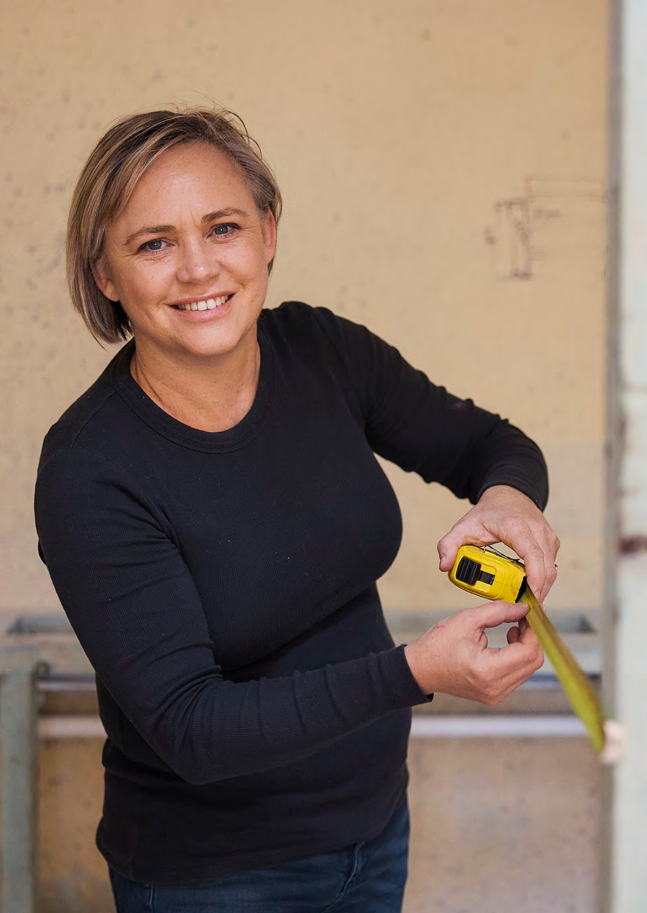
Vale Ricky
1
In 2022, the team lost a friend and colleague, Ricky Chalmers, to cancer. Ricky, who was a Maintenance Handyperson, was known for being funny and warm. He was known for his empathy for customers and showed genuine care and love for what he did and made a real difference to their experience with SGCH.
Teresa said: “He was part of the SGCH family and losing him was tough for all of us. We had some great support from SGCH. We took on a small project at Riverwood so we could be close to him, and he could come and visit us and have coffee. A few of the company staff sent him dinners and donated food vouchers so it was lovely to know that the St George team would always look out for us.”
[Image Captions:]
1. Teresa, Handyperson Coordinator, loves making SGCH's communities better for our customers
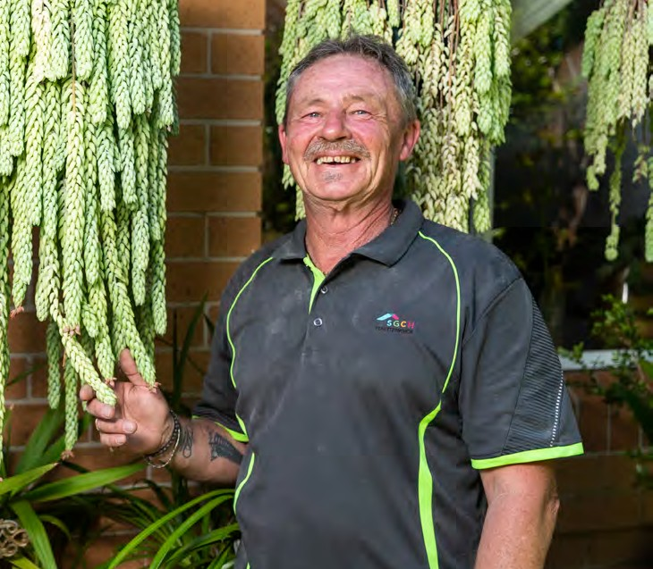
2. Ricky Chalmers was known for being funny and warm
2
1
2
<pp>80-81

Gibbons Street, Redfern

Awards won
Urban Taskforce Development Excellence Awards 2021
Affordable Development
PowerHousing 2021
Team/Organisation Award Program Leadership and Government Collaboration Award
Australian Disability Service Awards 2021
Best Accommodation Provider in partnership with Civic Disability Services for our My Home –Redfern program
UDIA NSW Crown Group Awards for Excellence 2022
Affordable Development
<pp>82-83
[Image captions:]
- Yarning circle on the level 3 playground
- Group CEO Scott Langford hosts an investor tour for NHFIC
- The striking facade is curved to increase privacy and reduce wind
- SGCH team members hosting a barbecue for customers
- Investors learn more about our work at a site tour
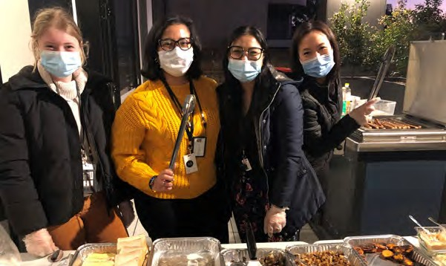
- Level 3 playground provides a welcoming and private space for customers
4
- Solar panels and a battery storage system power the common areas of the building
- Level 17 rooftop common area with sweeping views across Greater Sydney
<pp>84-85

New homes FY21/22
1
Social housing
SGCH is the largest community housing provider and developer of social and affordable housing in Sydney.
35
Affordable housing
We have a dedicated in-house team experienced in development and project management, across residential and major urban regeneration projects. Since 2014 we have delivered 995 new units across Greater Sydney, building to a minimum 7-star NatHERS rating target. In the past year alone, we have delivered 121 new homes with a further 288 in stages of construction, planning or through an acquisition program.
- 1 Social housing
- 35 Affordable housing
- 121 New homes
- 56 days Lost to weather
- 0/56,281 Lost time injury/work hours
- 288 Units secured in our pipeline
- 85 Key worker housing
<pp>86

New Homes

Highline, Westmead
With funding from investment partner Lighthouse Infrastructure, SGCH acquired 85 apartments valued at $59 million, which are within the Highline development completed by leading Sydney developer and builder, Deicorp. Highline is located just 500m from Westmead Hospital and 100m from Western Sydney University campus. The tenancies are managed by SGCH, with key worker tenants meeting the criteria of low to moderate income bands, and working in designated sectors such as emergency services, health, and education.
[Image captions:]
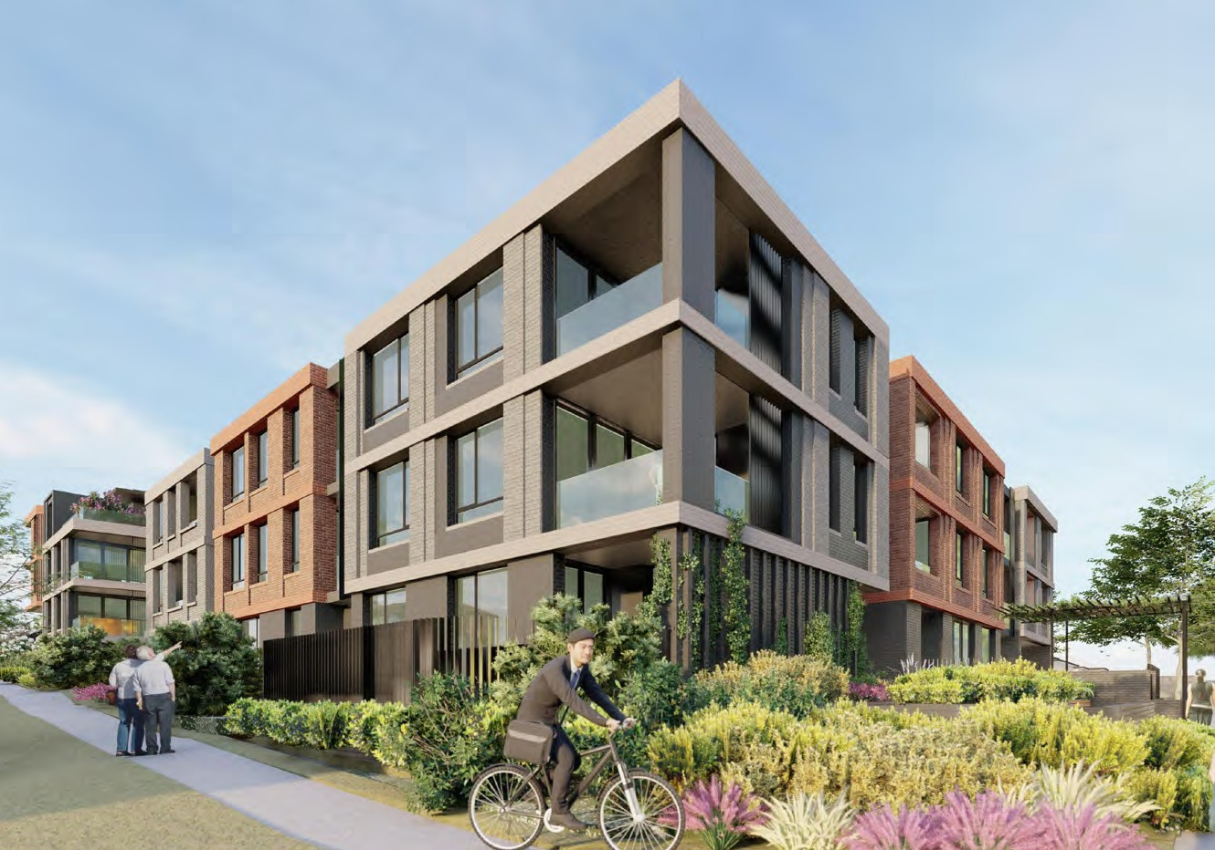
- Apartments at the Highline, Westmead development
4
- Light-filled bedroom opens on to the private balcony at Highline
- Render image of Pennsylvania Road, Riverwood. The development is under construction
- Detail render shows the corner view of the Pennsylvania Road, Riverwood development
<pp>87

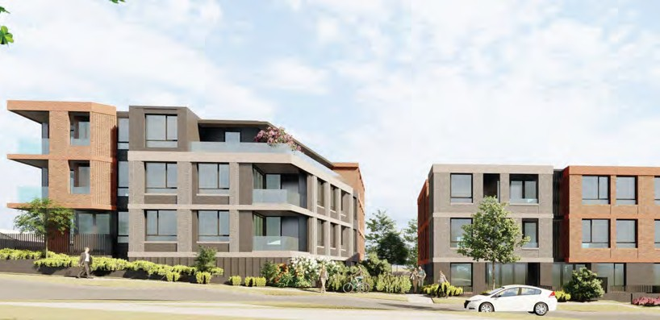
Pennsylvania Road, Riverwood
3
Located on the southern side of Pennsylvania Road, close to shopping, school and transport, this project began construction following Development Consent in June 2021. With 51 units in two separate four storey buildings, we anticipate this new social and affordable development will become a home to at least 120 new SGCH customers with its mix of one and two-bedroom homes. Six of the homes will be adaptable.
<pp>88

Gladstone Street, Newtown
Completed by a private development partner in October 2021, Gladstone Street in Newtown is a modern building with 21 residential apartments. The Inner West LGA has a high need for social and affordable housing, especially for older women and women who have experienced domestic violence. This development fills some of that demand. With a mix of studios, one, two and three-bedroom homes, the building uses a range of energy efficient solutions including solar panels on the roof, which runs the common area lighting and lifts, double glazed glass, high performance insulation in the floors, walls and ceilings, and ceiling fans.
[Image captions:]
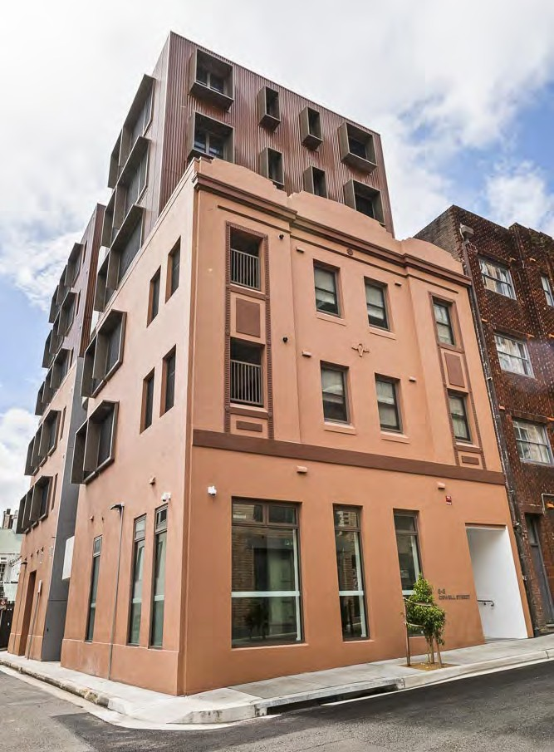
- Gladstone Street, Newtown
4
- Private and spacious balcony at Gladstone Street
- Minister Natasha Maclaren-Jones, joined by Alex Greenwich MP and Group CEO Scott Langford, cuts the ribbon to officially open the site
- Orwell Street, Potts Point rejuvenates the original facade and provides new, modern apartments and a community space
<pp>89

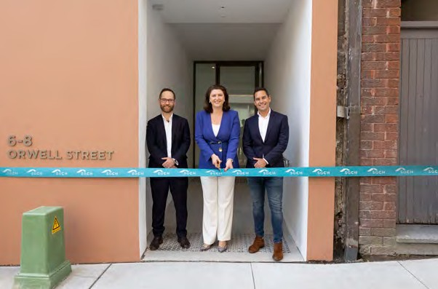
Orwell Street, Potts Point
3
Completed in September 2022 by a private development partner, Orwell Street is a five-storey modern building delivering 15 new sustainable and affordable homes, 14 affordable and one social, to the Potts Point community. There is a mix of studio (5), one (8) and two (2) bedroom units, common area space with lounge area, a kitchenette and an area for work or study, and a bike storage room.
<pp>90

Nana’s story
Collaborative approaches like our partnership with Lighthouse Infrastructure offer an innovative solution to key worker housing affordability and benefit the communities where these workers are most needed.
Nana, a 22-year-old undergraduate student and a part time youth worker, values the convenience of living at the Highline development in Westmead because of the easy access to his university, work and community.
“I have access to almost everything: a train station, hospital, shops, and the chemist. Good public transport also means family and friends can visit without any hassles,” said the final year student, who moved into Highline in January this year.
“If I am having a lazy day, I can simply walk two minutes to a café or a restaurant to purchase food and when I need a break from studying, I can walk to Parramatta Park or the nearest gym to be active.”
Sky-rocketing rents, a hot housing market and high cost of living severely limits choices for those pursuing study and work in Sydney. The 85 brand new apartments at Highline provide much needed accommodation for key workers in sectors like emergency services, health, and education.
For Nana, who moved to Australia with his family in 2003 and has mostly lived in Western Sydney, Highline has allowed him to plan for his future.
“Knowing that I can afford housing that is in pristine condition and within proximity to work and university allows me to have peace of mind and live a productive life. I have so many options at my doorstep that I would not otherwise be able to afford and enjoy.”
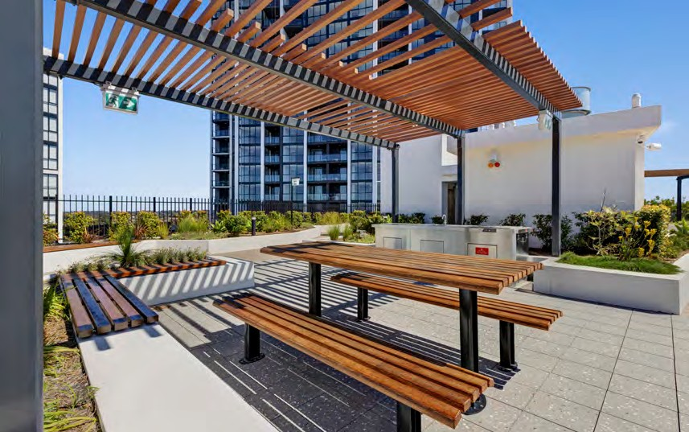
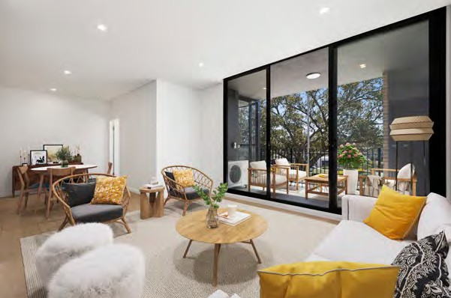
"I can save more money and think about my future goals without the added stress of having to pay full price to live a comfortable life."
2
3
— Nana
<pp>91
[Image captions:]
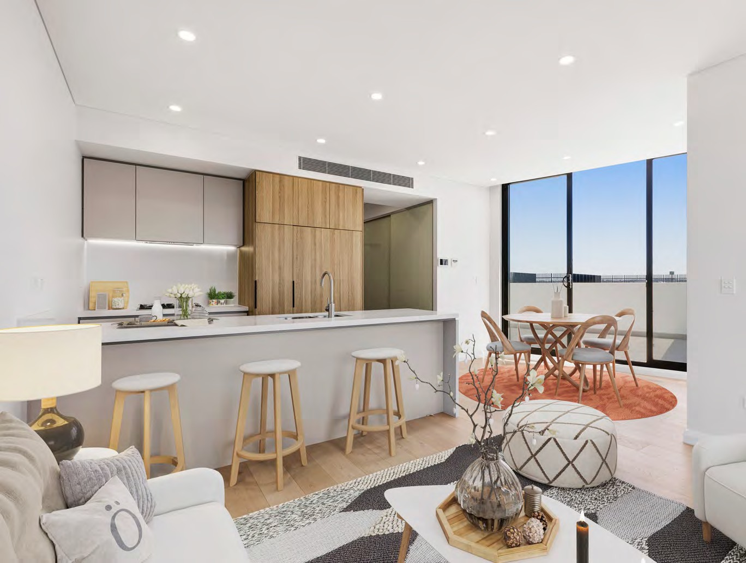
- Apartments feature high quality, modern finishes
1
1
- Common areas are a place for connection and community at Highline
2
- This living area opens to a generous balcony
3
<pp>92-93

People and culture FY21/22
29
Contractors
70%
Female
Our people are vital to our success. We are focused on attracting, retaining and developing an engaged and capable team who deliver together with passion and purpose, guided by our values of Innovation, Support, Accountability, Respect and Integrity.
236
Employees
- 236 Employed
- 86% Retention rate
- 29 Contractors
- 70% Female
- 2,372 Enrolments in 56 learning and development courses
- 47 Average age of employees
- 115 Participants in 12 health & wellbeing events
- 3.98 Employee Engagement score Gallup Q12
- 30% Male
<pp>94

People and Culture

Engaged employees
SGCH has been measuring employee engagement through the Gallup Q12® Employee Engagement Survey since 2017.
The Gallup® approach identifies 12 core elements that link powerfully to key business outcomes and best predict employee engagement and performance. SGCH adopts a leading approach to foster the potential of our team members, using the Gallup Clifton Strengths tool as a personal and team development activity. In 2022, our results showed a drop in engagement and satisfaction.
We ran the Gallup Q12 Employee Engagement Survey between 12-27 September 2022 with an impressive 88% response rate, up 8% from the previous survey in 2020. We saw a decrease in the Employee Engagement Score or Gallup Q12 Mean to 3.98 out of 5 (4.14 in 2020). Broadly speaking, we observed changes in engagement and satisfaction that reflect global workforce trends. While this is a drop compared to the steady gains made in previous periods, in the context of significant changes in both the external and internal environment the result is understandable and within an accepted range.
Pleasingly, our strongest responses were for questions related to values, with 50% strongly agreeing that ‘The mission or purpose of my company makes me feel my job is important’, and 56% strongly agreeing ‘My manager, or someone at work, seems to care about me as a person.’

Reward and recognition
We promote positive engagement and retention with a focus on rewards and recognition. While performance is key, we also promote our values, encouraging team members to live our organisational behaviours. Rewards and recognition include our ISARI Values award, GEM (Going Extra Mile) award, Thank You program and Manager’s appreciation incentives.
Our teams are employed under either the Social, Community, Home Care and Disability Services Industry Award (SCHCADS) or an individual employment contract. SGCH pays above award minimum rates.

Employee engagement score over time.
[The following graph has been tabulated here:]
Year | Employee engagement score
2017 | 3.27
2018 | 3.92
2019 | 4.11
2020 | 4.14
2021 | n/a
2022 | 3.98
<pp>95

Learning and development
SGCH fosters a culture of continual learning and development for team members through a range of formal and informal training and learning opportunities. Our online Learning Management System, Apollo, provides flexibility and choices for staff to manage their own eLearning experience such as the roll out of updated discrimination, harassment, and bullying training which all team members completed. In the past financial year, other activities included:
- Social Work Supervision program
- Liberated Leaders program
- Training for Customer Care Hub, 8x8 and SAMP and Disaster Management (internal)
- Community Housing Industry Association Cadetship Support
- Empower You to Lead program.

Safety
We are committed to a culture of safety for the benefit of our customers and team members. A key priority has been to manage COVID-safe approaches that enable our teams to perform their roles and continue to meet the needs of our customers safely and flexibly. This has been guided by the SGCH Resilience Coordination Committee, which acts as a consultation channel for staff.
After the NSW lockdown restrictions began to ease in late 2021, the committee undertook organisation-wide consultation on how each team would best deliver services for customers, balancing these requirements in a hybrid setting with staff working from offices, visiting customers homes, working on sites and from home. This allowed flexibility that considered the different needs and ways of working at a team-level.

Health and wellbeing
The past couple of years have reshaped how we operate as a society. It’s more important than ever to support health and wellbeing. Through our employee assistance program, all team members and their immediate family have access to confidential counselling to assist with personal and work-related issues. Our Recharge program balances five pillars of wellbeing: physical, emotional, social, economic and mental. SGCH offered 30 initiatives in the past year, ranging from financial seminars, skin checks, flu vaccinations, yoga classes and walking groups. Additional leave was also in place for staff members to access COVID-19 vaccination appointments.
" I love my team. I love what we do as an organisation and I know that every day I contribute to helping our customers and ensuring they have a great place to live.
– Julia, Lead, Central Services Operations
<pp>96

Workforce insights
Under the Workplace Gender Equality Act 2012 (WGEA), non- public sector employers with 100 or more staff must report annually against six gender equality indicators. The reporting results are a snapshot at a point in time, submitted in May 2022.
Indicator | Overview
Workplace overview | - YES  Formal policy and/or strategy in place to support gender equality overall  - NO  Formal policy or strategy in key performance indicators for managers relating to gender equality  - YES  Formal policy or strategy in recruitment  - YES  Formal policy or strategy in promotions
Action on gender equity | - YES  Specific pay equity objectives included in your formal policy and/or formal strategy  - YES  Formal policy and or/ strategy on remuneration generally  - YES  Analysis of payroll to determine if there are any remuneration gaps between women and men
Employment support | - YES  Formal policy and/or strategy to support employees experiencing family or domestic violence  - YES  Provision of employer funded paid parental leave, regardless of carer's status and in addition to any government funded parent leave scheme  - YES  Formal policy and/ or strategy on sex-based harassment and discrimination prevention
Flexible work | - YES  Formal policy and/or strategy on flexible working arrangements
Governing body | - YES  Governing body for this organisation  - YES  Formal selection policy and/or strategy for governing body members  - NO  Target set to increase representation of womens on the governing body*  *Some companies may not have a target Board composition if the Board is currently gender balanced
<pp>97

Gender pay gap
Organisation-wide gender pay gap for total remuneration 17.4%*
17.4%*
Pay gap favours men
*The gender pay gap excludes voluntary salary data submitted for your CEO, Head of Business(es), and KMP/HOBs. It also excludes employees who did not receive any payment during the reporting period. Gender X is excluded while the Agency establishes the baseline levels for this new data point.

Workforce composition
Key: Orange: Female
Green: Male

Management
- Female: 62.3%
- Male: 37.7%

Non-management
- Female: 68.6%
- Male: 31.4%

Employment status
- Female, Full time: 59.6%
Full time
- Male, Full time: 32%
Full time
- Female, Part time: 7.5%
Part time
- Male, Part time: 0.9%
Part time

Top occupation by gender

Female:
- 62: Community and personal service
- 41: Clerical & administration
- 33: Managers
- 17: Professionals

Male:
- 20: Managers
- 16: Community & personal service
- 15: Professionals
- 8: Clerical & administration.

Employment growth and promotion

Growth

Managers
- Female 2 UP
- Male 1 UP
- Female: 18 UP
- Male: 7 UP

Non-managers

Promotion

Managers
- Female: 4
- Male: 2

Non-managers
- Female: 8
- Male: 1
<pp>98

Financial sustainability
As a for-purpose organisation with a Board of professional non-Executive Directors, we ensure strong financial performance to reinvest our surplus towards delivering strategic outcomes. We focus on leveraging partnerships to solve complex challenges.
Our growth over time | 2018 | 2019 | 2020 | 2021 | 2022
Homes | 4,756 | 6,402 | 6,557 | 6,927 | 7,068
Customers | 9,185 | 11,048 | 11,292 | 11,371 | 11,437
Staff | 178 | 202 | 205 | 225 | 236
Annual maintenance spend | $12,862,658 | $12,194,909 | $20,053,169 | $23,482,284 | $19,042,801
Total revenue | $70,754,091 | $86,784,457 | $95,881,700 | $109,014,050 | $114,639,000
Total expenditure | $67,999,072 | $60,074,944 | $82,645,996 | $72,290,736 | $85,746,000
Surplus (Deficit) | $14,871,658 | $47,924,433 | ($18,620,791) | $23,700,281 | $9,471,858
Total assets | $713,884,410 | $886,037,697 | $1,070,654,120 | $1,257,887,515 | $1,283,435,623

We take a strategic and holistic approach to managing financial resources to ensure the most effective, efficient and economical services for our customers. We combine our social purpose and commercial expertise to provide sustainable, safe and affordable homes. We apply this thinking across our entire operations and strive to be a vibrant, sustainable business.
[The following pie-chart has been added to the table (% column)]
Revenue | $'000 | %
From tenants | 83,930 | 73
From government | 28,638 | 25
Other revenue | 2,071 | 2
Total | 114,639 | 100
[The following pie-chart has been added to the table (% column)]
Expenses | %'000 | %
Property | 35,661 | 34
Staff | 26,653 | 25
FV loss on ROU assets | 14,666 | 14
Net financial cost | 13,355 | 13
Other expenses | 8,642 | 8
FV loss on owned assets | 4,755 | 5
Depreciation | 1,435 | 1
Total | 105,167 | 100
<pp>99

Financial performance
This year, we have grown to around$1.3 billion in assets on balance sheet and approximately $3.7 billion in assets under management. Our overall performance has been very strong. For detailed information about SGCH Group financial performance, please refer to the Directors’ Report and Summary Financial Statements 2021/22 (page 114).

Our growth over time | 2018 | 2019 | 2020 | 2021 | 2022
Homes | 4,756 | 6,402 | 6,557 | 6,927 | 7,068
Customers | 9,185 | 11,048 | 11,292 | 11,371 | 11,437
Staff | 178 | 202 | 205 | 225 | 236
Annual maintenance spend | $12,862,658 | $12,194,909 | $20,053,169 | $23,482,284 | $19,042,801
Total revenue | $70,754,091 | $86,784,457 | $95,881,700 | $109,014,050 | $114,639,000
Total expenditure | $67,999,072 | $60,074,944 | $82,645,996 | $72,290,736 | $85,746,000
Surplus (Deficit) | $14,871,658 | $47,924,433 | ($18,620,791) | $23,700,281 | $9,471,858
Total assets | $713,884,410 | $886,037,697 | $1,070,654,120 | $1,257,887,515 | $1,283,435,623

Commercial approach
SGCH has a demonstrated track record of successfully raising capital at scale and delivering outcomes based on complex transactions. This is evidenced by the financial strength of SGCH Group, which has an annual revenue of approximately $100 million, assets valued at $1.3 billion on balance sheet, net assets of $676 million.
We understand that solving the challenges of our housing system requires both public and private participation, and requires the innovation and ideas of different industries.
We see our role as being a crucial partner with the capability, expertise and vision to draw in a range of complementary organisations to achieve change and improve outcomes for individuals and communities.
Increasingly, social and affordable housing is recognised as an investment class offering the benefits of low- volatility, long-term demand and the assurance of being highly regulated. With COVID-19 causing market volatility, impacts on supply chains, movement of people and a range of factors, investors have come to appreciate the stable economic return and incredibly high social return available from this emerging global asset class.
Our aim is to:
- unlock land owned by governments or aligned partners for affordable housing in the right locations. To access this land, we use available planning and tax concessions to maximise value through the delivery of affordable housing as stand-alone assets or as part of larger developments
- manage development risk and create construction and whole-of- life operational efficiencies. To do this, we use our expert in-house development team to drive long-term value for money through design and construction, and the adoption of innovative procurement practices
- deliver efficiencies in operations and maintenance through our growing scale and concentration in Sydney, using our proven capability to optimise operating phase efficiencies, and
- create innovative financing structures that utilise efficient access to capital, priced to reflect the steady returns and low volatility.
<pp>100


Solving complex challenges in partnership
For young people leaving out of home care, transitioning to independent living can present unique challenges. The foyer approach provides the support and services needed to help build skills, confidence and friendships. Foyer Central is the first purpose-built foyer in NSW, and the first in the world funded by a social impact bond.
At Foyer Central, Tenancy Manager Amber has a rewarding role in supporting young people who have come out of foster care and moved into the two-year program, to confidently transition to independent living, and have stable tenancies.
“Foyer Central is an extension of out of home care. Rather than ending their support at 18 and saying go navigate the big wide world, they are given up to two years of supported accommodation at Foyer Central to get assistance with independent living skills,” said Amber.
During their stay, the young adults are given coaching on-site further down to develop life skills tailored to their interests. Coaches spend time with them exercising, cooking, training, helping build their resumes and finding employment. They help them navigate their early independent years while they continue studying, doing apprenticeships, training or working. Young people also have access to Uniting’s support workers 24/7 and on- site psychologists.
Amber goes beyond just preparing the young adults for stable tenancies. She works closely with the coaches to communicate how the young people are doing. For instance, if the young person has rental arrears, she liaises with coaches, who guide them on budgeting.
Having a good rapport with the young people and building trust is very important to Amber.
“I sometimes attend house meetings out of hours to listen, to look at the repairs that need to happen, or things they would like implemented. I work to build a rapport with the young people and treat them with respect and share my advice on how to manage the property.
I try to steer them in the right direction. I let them know they can come and talk to me with any questions or concerns.”
Seven years in the making, Foyer Central was officially opened last year. It represents a unique partnership between Uniting, SGCH, Social Ventures Australia, NSW Office of Social Impact Investment, the City of Sydney, and the NSW Department Communities and Justice. Located in the heart of the city, the building has 73 studio homes, with 20 affordable housing studios. The remaining 53 are dedicated to housing young people from out-of-home care between the ages of 18 to 23. It recently reached full capacity and all 53 apartments are occupied.
“We have created a vital opportunity for young people exiting the care system. At this time in their journey to independence, it is crucial they have access to stable housing, education opportunities and wraparound support to provide them with the skills required to live an independent life, which all young people deserve. Every time one of our young people succeeds, it means we have all succeeded,” said Paula Thum, Uniting’s Manager at Foyer Central.
At their 18-month mark at Foyer Central, Uniting and SGCH work with the young person to support their next housing journey.
“It is nice when we see some of the young people move in to live together. They form some great friendships here, and they are very supportive of each other because they have had similar journeys. It is most rewarding and satisfying to see them grow and develop,” said Amber.
<pp>101
"It is crucial they have access to stable housing, education opportunities, and wraparound support to provide them with the skills required to live an independent life, which all young people deserve."
— Amber
<pp>102
- 01 Overview
- 02 Approach
- 03 Performance

04 Financial report
<pp>103
Cartoon image omitted.
<pp>104
21/22
<pp>105

Summary consolidated financial statements 30 June 2022
- Corporate governance principles | - 106
- Committees | - 111
- Group structure | - 112
- Risk | - 113
- Directors’ report | - 114
- Discussion and analysis of the Summary Financial Statements | - 121
- Summary consolidated statement of profit or loss and other comprehensive income | - 122
- Summary consolidated statement of financial position | - 123
- Summary consolidated statement of changes in equity | - 124
- Summary consolidated statement of cash flows | - 125
- Notes to the summary financial statements | - 126
- Independent auditor’s report | - 132
Directors’ declaration | - 134
Content elements | - 135
<pp>106

Corporate governance principles
The SGCH Group is required to meet the Australian Charities and Not-for-profits Commission governance standards and the performance outcomes mandated in the National Regulatory System Community Housing (NRSCH), against which it reports annually to demonstrate compliance and maintain registration as a Tier 1 community housing provider. Additionally, the SGCH Group benchmarks against the best practice ASX Corporate Governance Council’s Principles and Recommendations (‘Recommendations’) in continually assessing and improving its processes and policies.

Principle 1
Lay solid foundations for management and oversight
- Corporate Governance Policy-principal features of the Group’s governance, including the role of the Group Board and its Committees, matters reserved to the Group Board, the mechanism for delegation to management, company secretarial accountability to the Group Board, directors’ access to independent advice, the customer’s voice in decision making, process for evaluating the performance of the Group Board and directors.
- Continuous evaluation of Board Committees.
- Annual review of the CEO’s performance. The CEO is responsible for evaluating the performance of the executive management team each year and the People and Culture Committee of the Group Board annually reviews this process and the development and maintenance of succession plans.
- The Group has a Diversity and Equal Employment Opportunity Policy. The Group Board has equal female and male representation, achieving its targets. The SGCH Group is a “relevant employer” under the Workplace Gender Equality Act. The Gender Equality Indicators are reported on pages 96-97.
- Tenant Coordination Panel is made up of up to 10 tenants from either a local tenant group, or from a cultural group (eg the Chinese Group). The panel connects tenants with the SGCH management team and other tenant groups. The panel meets at least four times a year and is guided by Terms of Reference.
- Management frameworks underpinned by the Risk Management Framework.
- Policies Including: Code of Conduct and Ethics; Conflict of Interest; Anti-bribery, Corruption, Gifts and Benefits Policy; Whistleblower Policy; Compliance Policy.
<pp>107

Principle 2
Structure the Board to be effective and add value
- All directors are independent non-executive directors and all Committees are independent.
- The People and Culture Committee assists the Group Board in considering the matrix of skills of directors to ensure that the Group Board composition reflects necessary areas of expertise and experience.
- Appointing directors against an assessment of skills of the Board. In 2022 the Group embarked upon a search for new directors to replace directors at the end of their maximum terms.
- Annual evaluations of the Board and assessment of directors. The Group appointed an independent consultant to review the Board in 2022.
- Program for inducting new directors and continuous review of directors education and professional development.

Principle 3
Instil a culture of acting lawfully, ethically and responsibly
- The SGCH Group clearly articulates and discloses its values to staff, customers and stakeholders.
- Code of Conduct and Ethics and Conflict of Interest Policy and all employees and directors declare their compliance at least annually.
- Conflict of interest, related party transaction and gifts registers are maintained.
- Material breaches are reported to the People and Culture Committee and/or the Audit and Risk Committee.
- Publicly available Whistleblowing Policy where reports are investigated and reported to the Audit and Risk Committee and the Board.

Principle 4
Safeguarding the integrity of corporate reports
- Wholly independent Audit and Risk Committee of which a key function is to oversee the integrity of the Group’s financial reporting and associated processes, including the appointment of the external auditor.
- Annually, the Group CEO and CFO provide the Board a declaration that, in their opinion, the financial records have been properly maintained and that the financial statements comply with the appropriate accounting standards and give a true and fair view of the financial position and performance of the Group and each of the companies and the opinion has been formed on the basis of a sound system of risk management and internal control which is operating effectively.
<pp>108

Principle 5
Make timely and balanced disclosure
- Compliance with all applicable regulatory requirements to make notifications and disclosures and keeps its stakeholders and customers informed of material information.

Principle 6
Respect the rights of members
- SGCH encourages customer participation and feedback in various ways including the Tenant Coordination Panel.
- The Annual General Meeting is conducted in accordance with the Recommendations for substantive resolutions being decided by a poll and the option to receive and send communications to SGCH electronically.
- Regular communication with customers is achieved in various ways via communications and updates and regular and personal engagement by our tenancy managers. Customers can contact us via a central Customer Care Hub. Our website and other publications (including the Annual Report) provide a high degree of detailed information about SGCH, its governance and avenues for communication with SGCH.

Principle 7
Recognise and manage risk
- The SGCH Group’s wholly independent Audit and Risk Committee assists
- the Group Board to monitor the effectiveness of the Group’s systems of internal controls, risk management and compliance, and monitoring the effectiveness and integrity of the internal and external audit functions.
- The Audit and Risk Committee each year reviews the Risk Management Framework and reports to the Group Board and external reviews are also conducted periodically.
- The Internal Audit function works to a Board approved audit plan for assessing compliance, focused on key and strategic risks, and monitors management’s responsiveness to audit findings.
- The Internal Audit function has a reporting line to the Chair of the Audit and Risk Committee.
- Annually, the Internal Audit function is self-assessed and reports these findings to the Audit and Risk Committee. The effectiveness of the function is periodically reviewed by an external auditor to ensure the function is conforming with the mandatory requirements of the International Professional Practices Framework (IPPF) issued by the Institute of Internal Auditors, including the International Standards for the Professional Practice of Internal Auditing and the IIA Code of Ethics.
<pp>109

Principle 8
Remunerate fairly and responsibly
- The People and Culture Committee’s role includes to assist the Board in setting the level of remuneration for directors and the Group CEO and approving the remuneration of senior executives.
- The People and Culture Committee oversees succession planning and advises the Board on annual performance targets and annual evaluation of the Group CEO’s performance.
<pp>110

Corporate governance

We are committed to corporate governance that ensures transparency and accountability to our stakeholders.
The SGCH Board sets and guides the strategic direction of the organisation and oversees its activities with an appropriate level of governance and risk management.
The directors have an appropriate mix and balance of skills, expertise, experience, diversity, and independence to effectively govern the organisation for the benefit of the customers and communities we serve. For director profiles, see page 115.
We are committed to gender equality and recognise the benefits of diversity on the Board. SGCH has adopted a target of a 40:40:20 gender mix. The skills and experience of directors are reviewed regularly to ensure alignment to the Group’s growth and strategic direction.

Skills matrix
Area of experience | Anna Buduls | Simon Shakesheff | Victoria Weekes | Annette Gallard | Karen Orvad | Barry Mann | Philip Fagan-Schmidt | Rajiv Viswanathan | Lianne Buck
Prior non-executive director | Y | Y | Y | Y | Y | Y | Y | Y | Y
CEO/Senior executive | Y | Y | Y | Y | Y | Y | Y | Y
Strategic finance/ Accounting | Y | Y | Y |  | Y | Y | Y | Y | Y
Property/ Housing development/ Procurement | Y | Y | Y | Y | Y | Y | Y | Y | Y
Government / Social policy development | Y |  | Y | Y |  | Y | Y | Y | Y
CHP industry/Social housing management |  |  |  | Y |  | Y | Y
Technology/ Information | Y |  | Y |  | Y |  |  | Y | Y
Legal |  |  | Y |  | Y | Y |  | Y | Y
Audit & risk | Y | Y | Y |  | Y | Y | Y | Y | Y
Community welfare | Y |  | Y | Y | Y |  | Y
Asset management | Y | Y |  | Y | Y | Y | Y | Y | Y
Human resources |  |  | Y | Y | Y | Y | Y | Y | Y
Infrastructure Investment (capital raising) |  | Y | Y |  |  | Y |  | Y | Y
ESG | Y | Y | Y |  | Y | Y | Y | Y | Y

<pp>111

Committees
The SGCH Group has four Board Governance Committees that assist with its duties to oversee strategic areas of business operation
An overview of their responsibilities follows, further details about meetings in the reporting period and attendance are on page 118. Committee charters are available on our website.

Board Governance Committees

[blue] Audit and Risk
Karen Orvad
Chair
Oversees the integrity of the Group’s financial reporting, monitoring the effectiveness of the Group’s systems of internal controls, risk management and compliance, and monitoring the effectiveness and integrity of the internal and external audit functions.

[yellow] Property Portfolio and Investment
Simon Shakesheff
Chair
Maintains oversight and strategic guidance of resources invested in homes. This includes review and oversight of strategy and systems for investment, review and recommending to the Board investment or development opportunities, monitoring the development pipeline, overseeing and monitoring strategic asset management, and long-term planning of portfolio asset management and investment. The charter includes reviewing safety systems and performance and environmental and sustainability initiatives with respect to development and maintenance activities and assets.

[green] Safety and Sustainability
Victoria Weekes
Chair (until 24 June 2022)
Barry Mann
Chair (from 24 June 2022)
Monitors and reviews culture relating to safety, environmental and social sustainability. This includes the Group’s approach to promoting and protecting health and safety of our workers, customers and others while pursuing strategic objectives, the environmental impact and strategies and initiatives adopted to improve environmental sustainability and the impact of our activities on customers, stakeholders and communities. The committee considers key risks, compliance and impact of relevant changes in the areas of safety, environmental performance and social impact.

[pink] People and Culture
Annette Gallard
Chair
Assists the Board to fulfil its statutory, corporate governance and oversight responsibilities in relation to the people, remuneration and culture of the Group, contribute to the development and review of people and culture strategies, systems and processes and to monitor and ensure the effectiveness and performance of the Board.
<pp>112

Group structure
SGCH and its subsidiaries are registered with the Australian Charities and Not-for-profits Commission.
The parent and subsidiaries SGCH Portfolio, SGCH Sustainability and SGCH DevCo are required to meet the governance standards and the performance outcomes mandated under the National Regulatory System Community Housing, against which it reports annually to demonstrate compliance and maintain registration as a Tier 1 community housing provider. SGCH Keys is not registered in this system, it is an unconsolidated structured entity.

Our group structure
a
n
c
e
a
n
d
R
i
s
k
l
i
a
n
c
e
L
e
g
a
l,
G
o
v
e
r
[The following vertical flowchart has been converted to a list:]
- St George Community Housing Limited
ACN 133 729 503
Tier 1 Community Housing Provider
a
g
e
m
a
n
a
g
e
m
e
n
t
f
r
a
n
a
m
l
a
u
e
d
i
t
w
L
o
e
r
C
a
k
r
n
o
i
n
g
m
a
n
d
m
D
e
u
n
o
y
n
be
i
r
s
t
e
c
u
o
r
i
r
t
y
R
e
g
is
t
r
a
t
P
i
o
o
n
l
a
i
n
c
i
e
s
a
n
d
P
r
o
c
e
d
u
r
e
M
a
n
Registration No: R4587141217
Established January 1985
- Branches to
  - [orange] 100% wholly owned subsidiary
  - Branches to three:
    - [blue] 1a. Management service agreement
- LOGO: SGCH Portfolio
- SGCH Portfolio Limited
- ACN 160 035 441
- Tier 1 Community Housing Provider Registration No: R48340725
- Established 2012
    - [blue] 1b. Management service agreement
- LOGO: SGCH Sustainability
- SGCH Sustainability Limited
- ACN 606 965 799
- Tier 1 Community Housing Provider Registration No: R584315092
- Established 2015
    - 2.
- LOGO: SGCH DevCo
- SGCH DevCo Limited
- ACN 644 304 254
- Tier 1 Community Housing Provider Registration No: R8168210823
- Established 2020
    - [blue] 3a. Management service agreement
    - [pink] 3b Unconsolidated structured entity
- LOGO: SGCH Keys
- SGCH Keys Limited
- ACN 650 371 529
- Established 2021
<pp>113

Risk
The Board has overall responsibility for risk management with a particular focus on risk appetite to achieve our overall strategic objectives.
We recognise risk in the context of a rapidly changing external environment including social, environmental, political and economic changes, all of which have the potential to impact our organisation. In December 2021, SGCH published its first Modern Slavery Statement, available on our website.

Our risk management approach
[The following onion-layer chart has been converted to a list, which reads from the inner to the outer:
- [green] Inner layer
  - Risk management
- [blue] Layer 1
  - Respond
  - Manage
  - Communicate
  - Monitor
- [pink] Layer 2
  - Policies and Procedures
  - Risk management framework
  - Safety and risk culture
  - Executive Management Team
- [yellow] Layer 3
  - IT and Cybersecurity
  - Legal, Governance and Risk
  - Learning and Development
  - Corporate Affairs
- [orange] Layer 4 (Outer layer)
  - Registration and compliance
  - External audit
  - Internal audit and Risk
<pp>114

Directors’ report
Your Directors present their report on the consolidated entity (referred to hereafter as ‘the Group’) consisting of St George Community Housing Limited (referred to hereafter as ‘the Company’ or ‘SGCH’) and its wholly-owned subsidiaries, SGCH Portfolio Limited, SGCH Sustainability Limited and SGCH DevCo Limited for the year ended 30 June 2022 and the auditor’s report thereon.

Directors
- Annette Gallard PSM
- Victoria Weekes
(Resigned 26 August 2022)
- Anna Buduls AO
- Simon Shakesheff
- Karen Orvad
- Barry Mann
- Rajiv Viswanathan
(Appointed 25 August 2021)
- Philp Fagan-Schmidt
(Appointed 25 August 2021)
- Lianne Buck
(Appointed 28 September 2022)
All Directors have been in office since the start of the financial year to the date of this report unless otherwise stated.

Company Secretaries
- Claudia Certoma
- Scott Langford

Principal Activities


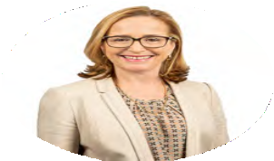
The principal activities of the Group during the financial year was the provision of housing services and assistance to low and moderate income earners. No significant change in the nature of these activities occurred during the year.
The Group is involved and has arrangements with many State and Federal government agencies. Any change in the policies of these government agencies may impact upon the way the Group performs its principal activity.
Annette Gallard PSM
Non-executive Director & Chair
Qualifications
B.Soc.Stud, M.Comm, GAICD
Experience
Annette joined the Board of SGCH in 2013 after nearly 30 years in the NSW Public Service. Annette held executive positions in both the Housing and Community Services Departments culminating in having responsibility for public housing and later for child protection, out of home care and the funding of thousands of
non-government services. After her retirement as Chief Executive Officer of Department of Community Services, she committed herself to supporting
not-for-profit organisations to take on greater responsibilities for the delivery of services to vulnerable people. As well as being Chair of SGCH, Annette is also Chair of a national disability not-for-profit provider. She was awarded the Public Service Medal in 2012 for services
to disadvantaged people including Aboriginal people.

Victoria Weekes
Non-executive Director & Vice Chair (Resigned 26 August 2022)
Qualifications
BComm LLB, FAICD, SFFinsia
Experience
A professional Director with over 30 years of experience as a senior executive in the financial services sector, Victoria is currently serving on several boards and has been Vice Chair of SGCH since 2018.
Victoria was formerly a director of ASX listed URB Investments Limited, Chair of the Audit and Risk Committee of Urban Growth Development Corporation, and Chair of NSW Treasury Audit and Risk Committee. Victoria is currently a director of Alcidion (ASX:ALC) and Bendigo and Adelaide Bank (ASX:BEN). Prior to her governance career, she held senior financial services executive positions with Westpac and Citigroup Australia and was formerly the Special Policy Advisor to the Australian Securities
Commission.

Anna Buduls AO
Non-executive Director
Qualifications
BA, M.Com
Experience
Anna is an experienced Non-Executive Director with business, not-for-profit and government policy experience. She has worked in investment banking and provided consulting services to private and government entities. For over two decades she has been on both Government and public company boards across a broad range of industries and sectors, including not-for-profit. She also has deep knowledge of and expertise in homelessness and with disadvantaged communities, garnered from both her government policy work and personal philanthropy. In 2003 Anna received a Centenary Medal for her community contributions. She was made an Officer of the Order of Australia in 2018 for distinguished service to the business and finance sectors through her advisory roles, and as a supporter and advocate for policy development to reduce homelessness, as well as her contributions to the welfare and charity sectors.

Operating Results
The surplus of the Group for the year ended 30 June 2022 amounted to $9.5 million (2021: $23.7 million). The reduction in the surplus compared to the prior year was primarily driven by a $4.8 million net reduction in fair value in investment properties (2021: increase of $12.4 million). The Group is exempt from income tax.
These consolidated financial statements are the first general purpose financial statements prepared in accordance with Australian Accounting Standards– Simplified Disclosures. In the prior year, the consolidated financial statements were general purpose financial statements prepared in accordance with Australian Accounting Standards– Reduced Disclosure Requirements.
There was no impact on the amounts recognised, measured and classified in the statements of financial position, financial performance and cash flows of the Group as a result of the change in basis of preparation.
<pp>115

Annette Gallard PSM
Non-executive Director & Chair
Qualifications
B.Soc.Stud, M.Comm, GAICD
Experience
Annette joined the Board of SGCH in 2013 after nearly 30 years in the NSW Public Service. Annette held executive positions in both the Housing and Community Services Departments culminating in having responsibility for public housing and later for child protection, out of home care and the funding of thousands of non-government services. After her retirement as Chief Executive Officer of Department of Community Services, she committed herself to supporting not-for-profit organisations to take on greater responsibilities for the delivery of services to vulnerable people. As well as being Chair of SGCH, Annette is also Chair of a national disability not-for-profit provider. She was awarded the Public Service Medal in 2012 for services to disadvantaged people including Aboriginal people.
Special Responsibilities
- Chair of the Board
- Chair of People and Culture Committee
- Member Audit and Risk Committee
- Member of Safety and Sustainability Committee

Victoria Weekes
Non-executive Director & Vice Chair (Resigned 26 August 2022)
Qualifications
BComm LLB, FAICD, SFFinsia
Experience
A professional Director with over 30 years of experience as a senior executive in the financial services sector, Victoria is currently serving on several boards and has been Vice Chair of SGCH since 2018. Victoria was formerly a director of ASX listed URB Investments Limited, Chair of the Audit and Risk Committee of Urban Growth Development Corporation, and Chair of NSW Treasury Audit and Risk Committee. Victoria is currently a director of Alcidion (ASX:ALC) and Bendigo and Adelaide Bank (ASX:BEN). Prior to her governance career, she held senior financial services executive positions with Westpac and Citigroup Australia and was formerly the Special Policy Advisor to the Australian Securities Commission.
Special Responsibilities
- Vice Chair of the Board
- Member of Safety and Sustainability Committee
- Chair of the Safety and Sustainability Committee to 23 June 2022
- Member of Property Portfolio and Investment Committee to 27 August 2021
- Member of People and Culture Committee

Anna Budus AO
Non-executive Director
Qualifications
BA. M. Com
Experience
Anna is an experienced Non-Executive Director with business, not-for-profit and government policy experience. She has worked in investment banking and provided consulting services to private and government entities. For over two decades she has been on both Government and public company boards across a broad range of industries and sectors, including not-for-profit. She also has deep knowledge of and expertise in homelessness and with disadvantaged communities, garnered from both her government policy work and personal philanthropy. In 2003 Anna received a Centenary Medal for her community contributions. She was made an Officer of the Order of Australia in 2018 for distinguished service to the business and finance sectors through her advisory roles, and as a supporter and advocate for policy development to reduce homelessness, as well as her contributions to the welfare and charity sectors.
Special Responsibilities
- Member of People and Culture Committee
- Member of Audit and Risk Committee
- Member of the Property Portfolio and Investment Committee from 27 August 2021
<pp>116

Simon Shakesheff
Non-executive Director
Qualifications
M Comm
Experience
Simon has over 30 years of analysis, advisory and operational experience in finance and real estate. He spent 19 years as the head of listed real estate analysis at Macquarie Bank and JPMorgan, before becoming a corporate advisor to listed real estate groups at UBS and Bank of America Merrill Lynch. He also has operational experience at Stockland Trust Group, where he was responsible for Strategy, Research and Stakeholder Relations, and a member of the Executive Committee. Simon is currently the Chair of HomeCo Daily Needs REIT (ASX: HDN), and a non-executive director of Kiwi Property Group (NZX: KPG), Cbus Property, and Assembly Funds Management. He has had a longstanding interest in housing and is a member of the National Housing Finance and Investment Corporation's research reference group.
Special Responsibilities
- Chair of the Property Portfolio and Investment Committee
- Member of Safety and Sustainability Committee to 27 August 2021
- Member of the Audit and Risk Committee from 27 August 2021.

Karen Orvad
Non-executive Director
Qualifications
GAICD, CAANZ, MBA(Exec), BComm (Accounting)
Experience
Karen is a professional Non-Executive Director and former KPMG Partner with a speciality in Governance, Risk Management and Internal Audit. She brings over 25 years experience working with some of the worlds' most recognised brands in governance, risk, internal audit, board advisory and strategic human resources. Karen has worked with corporate, government and NFPs across sectors including Health and Human Services, Energy, Transport, Retail and Financial Services. Karen has held senior executive internal audit and risk roles within top ASX listed companies in Financial Services and Aviation. Karen is also Deputy Chair of a national disability not-for-profit provider and a member of NSW Treasury Audit and Risk Committee.
Special Responsibilities
- Member of Audit and Risk Committee
- Chair of the Audit and Risk Committee
- Member of Safety and Sustainability Committee
- Member of People and Culture Committee from 4 February 2022

Barry Mann
Non-executive Director
Qualifications
GAICD, Graduate Diploma in Applied Finance and Investment (FINSIA), BE (Civil)
Experience
Barry has over 30 years experience as a senior executive in the property industry. His experience includes over 20 years in listed Australian property companies including six years in international postings as Managing Director and Chief Operating Officer. He has local and state government experience including as the Chief Executive of the NSW Government urban renewal organisation. Barry brings to the Board extensive and diverse experience in urban renewal, property development, housing, major transactions, design and construction, infrastructure delivery, international business, joint venture management and government enterprises. He is currently the Independent Chairman of Firefly Funds Management, a Nonexecutive Director of Birribee Housing (formerly NSWALC Housing Ltd) and Auckland Real Estate (AKL.ASX and AKL. NZX), and an independent Advisor to the Boards of Ingham Property Group and Taylor Australia.
Special Responsibilities
- Member of People and Culture Committee to 27 August 2021
- Member of Property Portfolio and Investment Committee
- Member of Safety and Sustainability Committee
- Chair of the Safety and Sustainability Committee from 24 June 2022
<pp>117

Rajiv Viswanathan
Non-executive Director (appointed on 25 August 2021)
Qualifications
BALLB
Experience
Rajiv has over 20 years experience across the public, private and community sectors, gained in diverse roles in New York, London and Sydney. Most recently he was the CEO of Indigenous Business Australia (IBA), a commercially-focused statutory corporation that supports Aboriginal and Torres Strait Islander people to own their own homes, start and grow businesses, and make investments. He previously worked in various roles with the Macquarie Group in New York and Sydney, in business development and risk management. Prior to this, he worked as a corporate lawyer in London and Sydney. Rajiv has extensive experience across a range of commercial transactions, including establishing new businesses, acquisitions, joint ventures, investment funds and capital raising, including in cross-border contexts. He is passionate about developing and applying commercial solutions to create social impact. He is an advisor to institutional investors on impact investment, and is a non-executive Director of Life Without Barriers, the First Nations Foundation and Head Start Homes.
Special Responsibilities
- Member of Property Portfolio and Investment Committee from 27 August 2021
- Member of Audit and Risk Committee from 27 August 2021

Philip Fagan-Schmidt PSM
Non-executive Director (appointed on 25 August 2021)
Qualifications
M Policy and Admin, BA
Experience
Philip has had an illustrious career in social housing, having held the position of Executive Director of Housing SA for almost a decade with responsibility for 40,000 social housing properties. He offers insights from his leadership of a large organisation in Housing SA, overseeing 1,000 staff, a $10 billion asset base and an annual operational budget of $400 million. Philip is experienced in policy and strategy, natural and urban resources; and the disability, community services and aged care sectors. He has served on significant national and local Boards and Committees and has worked widely across Government agencies including the Premiers Department, Health, Community Services, and Housing. He is nationally recognised as an industry leader and was awarded a Queen's Birthday Public Service Medal for outstanding service in social housing policy and practice in 2015. Since leaving the South Australian public service in 2018, he has worked as a consultant and independent director and advisor.
Special Responsibilities
- Member of Property Portfolio and Investment Committee from 27 August 2021
- Member of People and Culture Committee from 27 August 2021

Lianne Buck
Independent Non-Executive Director (appointed 28 September 2022)
Qualifications
GAICD, B Comm (Accounting) Experience
Lianne is an experienced leader, combining current board and governance experience with a successful career as a senior investment professional, with over 20 years in Australian and global markets, focusing on infrastructure and real estate investments. She has experience in investment management, strategy, corporate finance, business transformation and government and stakeholder management. Lianne commenced her executive career in Canada as a Chartered Accountant with KPMG before working in various roles for Macquarie Group, Westpac Banking Corporation, Hastings Funds Management and NSW Treasury Corporation where she was Head of Direct Investments and Infrastructure and a member of their Investment Committee. She has a Bachelor of Commerce degree and is a graduate of the Australian Institute of Company Directors.
Lianne is currently a Non-Executive Director of Argo Investment Limited, ISPT Property Group and AusNet Services Limited. Lianne also serves on the Investment Committee of the St Ignatius College Bursary Fund.
Special Responsibilities
- Member of Audit and Risk Committee from 28 September 2022
<pp>118

Meetings of Directors
During the financial year, 9 meetings of Directors were held. Attendance by each Director was as follows:
 | Full  Board | Audit and Risk Committee | Property Portfolio & Investment Committee | People and Culture Committee | Safety and Sustainability Committee
Annette Gallard PSM | 9/9 | 5/5 | — | 3/3 | 3/3
Victoria Weekes | 9/8 | — | — | 3/3 | 3/3
Anna Buduls AO | 9/9 | 5/5 | 4/4 | 3/3 | —
Simon Shakesheff | 9/9 | 5/5 | 4/4 | — | 1/1
Karen Orvad | 9/9 | 5/5 | — | 1/1 | 3/3
Barry Mann | 9/9 | — | 4/3 | 1/1 | 3/3
Rajiv Viswanathan | 8/7 | 5/5 | 4/3 | — | —
Philip Fagan-Schmidt PSM | 8/8 | — | 4/3 | 2/2 | —
/ = Meetings eligible to attend/Meetings attended
— = Not a member of the stated Committee
<pp>119

Remuneration of the Directors
During the financial year the remuneration of the Directors amounted to $261 thousand (2021: $245 thousand)

Company Secretary’s qualifications
Claudia Certoma
BEc (Hons I), LLB (Hons I), GradDip ACG, AGIA ACG (CS, CGP), Solicitor (NSW, HCA)
Scott Langford
MBA, P.GradDip Prop. Dev., FIML, FAICD, MRICS

Strategy for achieving the corporate objectives
The Group’s Strategic Plan identifies the three key outcomes we aspire to achieve, being: Sustainable Tenancies as a Foundation for Opportunity, More Sustainable Homes in Thriving Communities and A Vibrant, Sustainable Business. All projects and initiatives are assessed against achievement of these outcomes and are considered for social and financial return on investment in determining resource allocation and priority for implementation.
During the year we commenced the development of 51 units and committed to leasing a further 102 units of social and affordable housing to satisfy our remaining Social & Affordable Housing Fund Phase 2 commitments. It is expected all these homes will achieve service readiness before the end of the 2023 calendar year.
In December 2021, SGCH Keys Limited (SGCH Keys), an unconsolidated structured entity in which St George Community Housing Limited (SGCH) is the sole member, commenced operating for the public charitable object of providing relief against poverty, distress and helplessness. SGCH Keys acquired 85 Affordable Housing units (Key Worker Housing) funded via a loan arrangement with Lighthouse Affordable Rental Investments (LARI). SGCH entered into a Management Services Agreement with SGCH Keys to provide tenant and asset management and other services to SGCH Keys on a fee-for-service basis.

Future Developments-Short and Long Term Objectives of the Group
SGCH is committed to being a sustainable business that creates and protects financial and non-financial value and shares the benefits with our customers, partners and the communities in which we work. Environment, Social and Governance (ESG) objectives are at the core of our strategy and how we approach the creation and protection of value for our customers, the communities we serve, our partners and stakeholders.
Our strategy blueprint identifies the strategic drivers of success that will help us achieve our desired outcomes. The Group is focused on; offering efficient, customer centric services; partnering to create opportunity with values-aligned organisations; attracting new capital into an affordable and social housing asset class and originating projects to create more homes; providing value for money asset management to ensure safe and sustainable homes are optimized for customers and capital partners; aligning high performing people, processes and systems; and, consistently delivering as a partner of choice at the forefront of a thriving industry.
We are investing into our strategy by pursuing projects and initiatives which are aligned to our goals and ESG commitments in determining resource allocation and priority for implementation. The Group is focusing on; improving the efficiency of service delivery whilst continuing to support customers and staff; and creating more homes by identifying suitable property opportunities for social and affordable housing and mobilising investment from partners.
Continuing to support customers and staff throughout and beyond the COVID-19 pandemic remains crucial to achieving the long-term objectives of the Group.

Significant Events after the Reporting Date
SGCH Keys Limited, an unconsolidated structured entity in which St George Community Housing Limited is the sole member, exchanged contracts for the acquisition of 76 affordable housing units (Key Worker Housing) on 14 October 2022. The acquisition will be funded via the existing loan arrangement with Lighthouse Affordable Rental Investments (LARI). SGCH will manage the asset on a fee for service basis under the existing management services agreement with SGCH Keys.
Other than the foregoing, no matter or circumstance has arisen since 30 June 2022, that has significantly affected, or may significantly affect the Group’s operations, the results of those operations, or the Group’s state of affairs in future financial years.
<pp>120

Significant Changes in State of Affairs
There were no significant changes in the state of affairs of the Group during the financial year.

Environmental Issues
The Group’s operations are not regulated by any significant environmental regulation under a law of the Commonwealth or of a state or territory. The Group is governed by environmental regulations managed by local government as applied to residential properties. During the year the Directors are not aware of any particular or significant environmental issues which have been raised in relation to the Group’s operations.

Indemnifying Directors, Officers or Auditors
Deeds of Indemnity have been entered into between the Group and Directors and Officers that indemnify them from financial losses that may occur arising from the performance of their duties. No indemnities have been given during or since the end of the financial year for any person who is or has been an auditor of the Group.
Directors’ and Officers’ insurance premiums are paid by the Company. The policy prohibits the disclosure of amounts paid.

Proceedings on Behalf of the Company
No person has applied for leave of Court to bring proceedings on behalf of the Group or intervene in any proceedings to which the Group is a party for the purpose of taking responsibility on behalf of the Group for all or any part of those proceedings.
The Group was not a party to any such proceedings during the year.

Contributions on Winding Up
In the event of the Group being wound up, ordinary members are required to contribute a maximum of $2 each. The total amount that members of the Group are liable to contribute if the Group is wound up is $430, based on 215 current ordinary members.

Rounding off
The Group is of a kind referred to in ASIC Corporations (Rounding in Financial/ Directors’ Reports) Instrument 2016/191 and in accordance with that instrument, amounts in the consolidated financial report and directors’ report have been rounded off to the nearest thousand dollars, unless otherwise stated.
Signed in accordance with a resolution of the Board of Directors.
Annette Gallard PSM
Chair
Sydney, 14 October 2022
<pp>121

Discussion and analysis of the Summary Financial Statements

Basis of Preparation of the Summary Financial Statements
The Summary Financial Statements are an extract from the full financial statements for the year ended 30 June 2022. The financial statements and disclosures in the Summary Financial Statements have been derived from the 2022 consolidated financial statements of St George Community Housing Limited.
A copy of the full financial statements and auditor’s report will be sent to any member, free of charge, upon request.
The discussion and analysis is provided to assist members in understanding the Summary Financial Statements. The discussion and analysis is based on St George Community Housing Limited’s financial statements and the information contained in the Summary Financial Statements.
The financial statements are presented in Australian Dollars which is the Group’s functional and presentational currency.

Statement of Profit of Loss and Other Comprehensive Income
Total revenue and other income increased by $5.6 million to $114.6 million (2021: $109.0 million) mainly due to an increase in rent revenue by $6.2 million and SAHF monthly service payments (revenue) of $6.2 million. This was partially offset by the LAHC Stimulus Contract revenue received in 2021 of $5.8 million. No such contract was in place in 2022.
In addition to the above, the reduction in the surplus to $9.5 million (from $23.7 million in 2021) was mainly driven by a decline in the fair value of investment properties of $4.8 million (compared to a $12.4 million increase in fair value in 2021).

Statement of Financial Position
Total assets increased by $25.5 million to $1,283.4 million (2021: $1,257.9 million). The movement is mainly due to capital works added $7.1 million and net increase in right of use assets during the year of $12.4 million, partially offset by fair value decline in owned investment properties of $4.8 million, and net increase in bank balance and short-term investments by $9.2 million as a result of the operating surplus for the year.
Total liabilities increased by $16.1 million to $607.0 million (2021: $590.9 million). The increase is predominantly in relation to additional lease liabilities corresponding to the right of use assets.

Statement of Cash Flows
Cash flow movements during the financial year were positive as a result of increased grants received and lower payments to suppliers, which were partially offset by higher lease payments.

Statement of Changes in Equity
During the year ended 30 June 2022, $4.8 million was transferred from the Investment Property Reserve, which reflects the fair value loss on investment property for the year.
<pp>122

Summary consolidated statement of profit or loss and other comprehensive income
 | Note | 2022  $000 | 2021  $000
Revenue | 02 | 113,728 | 105,641
Other income | 03 | 911 | 3,373
Expenses
Property expenses |  | (35,661) | (38,621)
Employee benefits expense |  | (26,653) | (24,999)
Depreciation expense |  | (1,435) | (1,420)
Professional fees |  | (1,791) | (1,192)
Other expenses |  | (6,851) | (6,060)
Fair value (loss)/gain on investment property-owned |  | (4,755) | 12,357
Fair value loss on investment property-right of use assets |  | (14,666) | (13,173)
Fair value gain on derivative financial instrument |  | – | 1,850
Operating result |  | 22.827 | 37,756
Net financial cost |  | (13,355) | (14,056)
Surplus for the year |  | 9,472 | 23,700
Other comprehensive income for the year |  | – | –
Total comprehensive income for the year |  | 9.472 | 23,700
The Statement of Profit or Loss and Other Comprehensive Income is to be read in conjunction with the notes to and forming part of the financial statements.
<pp>123

Summary consolidated statement of financial position
[Note that the following table has been split into individual tables, where possible, for ease of reading]
 | Note | 2022  $000 | 2021  $000
Current assets
Cash and cash equivalents |  | 211,655 | 197,482
Short-term investments |  | 35,800 | 40,800
Trade and other receivables |  | 5,373 | 4,623
Other current assets |  | 4,237 | 2,868
Total current assets |  | 257,065 | 245,773
Non-current assets
Other non-current assets |  | 1,309 | 1,210
Loan to a related party |  | 668 | —
Property, plant and equipment |  | 4,346 | 5,516
Contract asset |  | 1,054 | 1,117
Investment property | 04 | 1,018,994 | 1,004,271
Total non-current assets |  | 1,026,371 | 1,012,114
Total assets |  | 1,283,436 | 1,257,887

 | Note | 2022  $000 | 2021  $000
Current liabilities
Trade and other payables |  | 10,668 | 9,982
Employee benefits |  | 3,699 | 3,538
Lease liabilities |  | 16,563 | 16,037
Unexpended grants |  | 4,878 | 2,210
Total current liabilities |  | 35,808 | 31,767
Non-current liabilities
Employee benefits |  | 225 | 384
Borrowings |  | 472,611 | 472,349
Lease liabilities |  | 97,491 | 86,374
Unexpended grants |  | 816 | —
Total non-current liabilities |  | 571,143 | 559,107
Total liabilities |  | 606,951 | 590,874
Net assets |  | 676,485 | 667,013

 | Note | 2022  $000 | 2021  $000
Equity
Accumulated surplus |  | 127,893 | 113,666
Investment property reserve |  | 548,592 | 553,347
Total equity |  | 676,485 | 667,013
The Statement of Financial Position is to be read in conjunction with the notes to and forming part of the financial statements.
<pp>124

Summary consolidated statement of changes in equity
 | Accumulated surplus  $000 | Investment property reserve  $000 | Total equity  $000
Balance at 30 June 2020 | 102,323 | 540,990 | 643,313
Surplus for the year | 23,700 | — | 23,700
Other comprehensive income for the year | — | — | —
Total comprehensive income for the year | 23.700 | — | 23,700
Transfer from reserves | (12,357) | 12,357 | —
Balance at 30 June 2021 | 113,666 | 553,347 | 667.013
Surplus for the year | 9,472 | — | 9,472
Other comprehensive income for the year | — | — | —
Total comprehensive income for the year | 9.472 | — | 9.472
Transfer from reserves | 4,755 | (4,755) | —
Balance at 30 June 2022 | 127,893 | 548,592 | 676,485
The Statement of Changes in Equity is to be read in conjunction with the notes to and forming part of the financial statements.
<pp>125

Summary consolidated statement of cash flows
 | 2022  $000 | 2021  $000
Cash flow from operating activities
Receipts from customers (inclusive of gst) | 94,426 | 97,556
Receipts of government grants (inclusive of gst) | 31,782 | 21,903
Payments to suppliers and employees (inclusive of gst) | (78,421) | (83,318)
Interest received | 502 | 370
Lease payments–interest | (4,641) | (5,313)
Finance costs paid | (8,956) | (8,803)
Net cash provided by operating activities | 34,692 | 22,394
Cash flow from investing activities | — | —
Decrease/(increase) in short-term investment | 5,000 | (30,795)
Proceeds from sale of investment properties | — | 1,423
Payment for investment properties | (8,413) | (80,280)
Payment for property, plant and equipment | (173) | (320)
Net cash used in investing activities | (3,586) | (109,973)
Cash flow from financing activities | — | —
Proceeds from borrowings | — | 250,000
Lease payments–principal | (16,265) | (14,608)
Loan to a related party | (668) | —
Repayment of borrowings | — | (87,805)
Repayment of derivative financial liability | — | (6,046)
Net cash provided by financing activities | (16,933) | 141,540
Net increase in cash held | 14,173 | 53,962
Cash at the beginning of the financial year | 197,482 | 143,520
Cash at the end of the financial year | 211,655 | 197,482
The Statement of Cash Flows is to be read in conjunction with the notes to and forming part of the financial statements.
<pp>126

Note 01

Basis of Preparation of the Summary Financial Statements
The Summary Financial Statements have been prepared from the audited financial statements for the year ended 30 June 2022. The audited financial statements for the year ended 30 June 2022 are available on request from St George Community Housing Limited.
The financial statements are presented in Australian Dollars which is the Group’s functional and presentational currency. The Group is of a kind referred to in ASIC Corporations (Rounding in Financial/Directors’ Reports) Instrument 2016/191 and in accordance with that instrument, all financial information presented in Australian dollars has been rounded to the nearest thousand, unless otherwise indicated.
The financial statements, specific disclosures and other information included in the summary financial statements are derived from and are consistent with the full financial statements of St George Community Housing Limited. The summary financial statements cannot be expected to provide a detailed understanding of the financial performance, financial position and financing and investing activities of St George Community Housing Limited as the full financial report.
The accounting policies have been consistently applied to St George Community Housing Limited and are consistent with those of the preceding financial year in their entirety.
<pp>127

Note 02
Revenue | 2022  $000 | 2021  $000
Revenue from tenants
Rent income | 81,917 | 75,746
Reimbursements | 2,013 | 1,974
Total revenue from tenants | 83,930 | 77,720
Revenue from government
CHLP-Tenancy management and maintenance funding (i) | 10,668 | 10,746
SHMT-Tenancy management and property management | 933 | 1,232
SAHF-Monthly services payments | 11,878 | 5,693
National Rental Affordability Scheme Incentives | 1,905 | 1,889
National disability insurance scheme | 1,295 | 1,010
Other | 1,959 | 785
Total revenue from government | 28,638 | 21,445
Other revenue
Insurance recoveries | 118 | 184
LHC stimulus (ii) | — | 5,768
Management fees | 1,042 | 524
Total other revenue | 1,160 | 6,476
Total | 113,728 | 105,641
(i) The CHLP provides funding for tenancy management activities, the maintenance of property and a component that is intended to compensate the Group for the excess of the market rent payable to private landlords over the rent earned from tenants who occupy the leased property. In accordance with AASB 15, the funding is wholly allocated as consideration for the housing services to be delivered in accordance with the contract and is recognised as the services are delivered. In July 2018, the NSW Government announced that FACS would provide a 10-year funding guarantee related to aspects of the Group’s CHLP social housing funding. The Group has not recognised this guarantee in the statement of financial position and entitlement to this funding is reassessed annually.
Revenue | 2022  $000 | 2021  $000
Revenue from tenants
Rent income | 81,917 | 75,746
Reimbursements | 2,013 | 1,974
Total revenue from tenants | 83,930 | 77,720
Revenue from government
CHLP–Tenancy management and maintenance funding (i) | 10,668 | 10,746
SHMT–Tenancy management and property management | 933 | 1,232
SAHF–Monthly services payments | 11,878 | 5,693
National Rental Affordability Scheme Incentives | 1,905 | 1,889
National disability insurance scheme | 1,295 | 1,010
Other | 1,959 | 785
Total revenue from government | 28,638 | 21,445
Other revenue
Insurance recoveries | 118 | 184
LHC stimulus (ii) | — | 5,768
Management fees | 1,042 | 524
Total other revenue | 1,160 | 6,476
Total | 113,728 | 105,641

02
(ii) In Financial Year ended 30 June 2021 the Group entered into a contract with LAHC to carry out structural repairs of properties and recognised the revenue towards provision of those services. No such contract was in place for the current financial year.
<pp>128

Note 03
Other income | 2022  $000 | 2021  $000
Gain on disposal of investment properties | — | 200
Contribution from City of Sydney for Youth Foyer Project (i) | — | 3,000
Donation income | 33 | 119
Fair Value Loan Adjustment | 65 | —
Sponsor Fee (ii) | 603 | —
Other income | 210 | 234
Total | 911 | 3,373
(i) In 2021 the Group received a grant from City of Sydney towards completion of the Youth Foyer Project. (2022: $Nil).
(ii) St George Community Housing Limited received from SGCH Keys Limited $603 thousand for the incorporation and the acquisition of 85 units of Key Worker Housing accommodation.

<pp>129

Note 04
Investment Property | 2022 $000 | 2021 $000
Investment property- Owned
Balance at the beginning of year | 905,359 | 813,727
Capitalised subsequent expenditure | 7,058 | 79,275
Change in fair value of investment property | (4,755) | 12,357
Total | 907,662 | 905,359
Investment property- Right of use leased assets
Balance at the beginning of year | 98,912 | 87,055
Additions of new properties to right of use assets | 36,476 | 32,332
De-recognition of terminated properties from right of use assets | (9,390) | (7,302)
Change in fair value of investment property | (14,666) | (13,173)
Balance at the end of the year | 111,332 | 98,912
Total | 1,018,994 | 1,004,271
Included within Investment property is a balance of $17.9 million (2021: $10.9 million) which relates to capital works in progress.
The majority of investment properties are leased to tenants on low to moderate incomes. The lease terms vary depending on the property provider and range from 2 weeks to 10 years rolling contracts.
The borrowings of the Group are secured by a registered mortgage over the Group’s investment properties.
<pp>130

Valuation basis
The fair value of owned investment properties has been determined with reference to independent valuations performed by registered property valuation companies that hold recognised and relevant professional qualifications and have recent experience in the location and category of the investment property. The valuations are prepared in accordance with established valuation methodologies, international valuation standards and Australian Accounting Standard AASB 13 Fair value measurements using the market approach. Fair value is measured using the assumptions that market participants would use when pricing the asset, assuming they act in their economic best interests. The fair value measurement is based on its highest and best use. Valuation techniques that are appropriate in the circumstances and for which sufficient data are available to measure fair value, are used, maximising the use of relevant observable inputs and minimising the use of unobservable inputs.
The fair value of leased property has been determined with reference to the present market rental earning capability under the leasehold interest (including for the non-cancellable period plus any further option to renew which is likely to be exercised), net of the present value of expected lessee obligations. The discount rate used is the Group’s estimated incremental borrowing rate of 4.00-5.00%. For private residential property leases negotiated on market terms, the carrying amount of the right of use asset reasonably approximates the carrying amount of the lease liability at the reporting date.
<pp>131
Cartoon image omitted.
<pp>132

Independent auditor’s report
To the members of St George Community Housing Limited
Report on the Summary Financial Statements

Opinion
We report on the Summary Financial Statements of St George Community Housing Limited (the Company) as at and for the year ended 30 June 2022. The Summary Financial Statements are derived from the audited financial statements of St George Community Housing Limited.
In our opinion, the accompanying Summary Financial Statements of the Group are consistent, in all material respects, with the Audited Financial Statements, in accordance with the basis of preparation described in the Summary Financial Statements.
The Summary Financial Statements comprise:
- Summary consolidated statement of financial position as at 30 June 2022
- Summary consolidated statement of profit or loss and other comprehensive income, Summary consolidated statement of changes in equity, and Summary consolidated statement of cash flows for the year then ended
- Related notes.
The Group consists of St George Community Housing Limited (the Company) and the entities it controlled at the year end or from time to time during the financial year.

Scope of the Summary Financial Statements
The Summary Financial Statements do not contain all the disclosures required by Australian Accounting Standards - Simplified Disclosure Framework and Division 60 of the Australian Charities and Not-for-profits Commission Regulation 2013 applied in the preparation of the Audited Financial Statements. Reading the Summary Financial Statements and this Auditor's Report thereon, therefore, is not a substitute for reading the Audited Financial Statements and our auditor's report thereon.

The Audited Financial Statements and our auditor's report thereon
We expressed an unmodified audit opinion on the Audited Financial Statements in our auditor's report dated 14 October 2022.
KPMG, an Australian partnership and a member firm of the KPMG global organisation of independent member firms affiliated with KPMG International Limited, a private English company limited by guarantee. All rights reserved. The KPMG name and logo are trademarks used under license by the independent member firms of the KPMG global organisation. Liability limited by a scheme approved under Professional Standards Legislation.
<pp>133

Responsibility of the Directors for the Summary Financial Statements
The Directors are responsible for the preparation of the Summary Financial Statements in accordance with the basis of preparation described in Note 1 to the Summary Financial Statements, including their derivation from the Audited Financial Statements of the Group as at and for the year ended 30 June 2022.

Auditor's responsibility for the Summary Financial Statements
Our responsibility is to express an opinion on whether the Summary Financial Statements are consistent, in all material respects, with the Audited Financial Statements based on our procedures, which were conducted in accordance with Australian Auditing Standard ASA 810 Engagements to Report on Summary Financial Statements.
KPMG
Stephen Isaac
Partner Sydney
14 October 2022
<pp>13418

Directors’ declaration
The Directors of the Group declare that the Summary Financial Statements of St George Community Housing Limited and the entities it controlled for the financial year ended 30 June 2022, as set out on pages 122 to 134:
Content elements | Reference | Page
Organisational overview and external environment
What does the organisation do and what are the circumstances under which it operates? | Our purpose Our presence Approach Performance | 08  16  20  44
External environment | Operating context Group Chair’s report  Group CEO’s report | 22  12  14
Governance
How does the organisation’s governance structure support its ability to create value in the short, medium and long term? | How we create value  Corporate governance principles Committees  Group structure | 24  106  111  112
Business model
What is the organisation’s business model? | Our business model Stakeholders Directors’ report | 26  38  114
Risks and opportunities
What are the specific risks and opportunities that affect the organisation’s ability to create value over the short, medium and long term, and how is the organisation dealing with them? | Group Chair’s report Group CEO’s report ESG overview Financial sustainability Risk | 12  14  34  98  113
Strategy and resource allocation
Where does the organisation want to go and how does it intend to get there? | Strategy  Group CEO’s report Areas of focus | 28  14  36
Performance
To what extent has the organisation achieved its strategic objectives for the period and what are its outcomes in terms of effects on the capitals? | FY21/22 snapshot Performance Financial report | 10  44  102
Outlook
What challenges and uncertainties is the organisation likely to encounter in pursuing its strategy, and what are the potential implications for its business model and future performance? | Operating context ESG commitment Areas of focus Directors’ report | 22  32  36  114
Basis of presentation
How does the organisation determine what matters to include in the integrated report and how are such matters quantified or evaluated? | About this report Materiality Strategy  Materiality assessment | 03  03  28  40

(a) are an extract from the full financial statements for the year ended 30 June 2022 and have been derived from and are consistent with the full consolidated financial statements of St George Community Housing Limited and the entities it controlled.
This declaration is made in accordance with a resolution of the Board of Directors and is signed for and on behalf of the Directors by
Annette Gallard PSM
Chair
Sydney, 14 October 2022
<pp>135

Content elements
[The following table has been converted to lists:]

Organisational overview and external environment
What does the organisation do and what are the circumstances under which it operates?
- Our purpose 08
- Our presence 16
- Approach 20
- Performance 44
External environment
- Operating context 22
- Group Chair's report 12
- Group CEO's report 14

Governance
How does the organisation's governance structure support its ability to create value in the short, medium and long term?
- How we create value 24
- Corporate governance principles 106
- Committees 111
- Group structure 112

Business model
What is the organisation's business model?
- Our business model 26
- Stakeholders 38
- Directors' report 114

Risks and opportunities
What are the specific risks and opportunities that affect the organisation's ability to create value over the short, medium and long term, and how is the organisation dealing with them?
- Group Chair's report 12
- Group CEO's report 14
- ESG overview 34
- Financial sustainability 98
- Risk 113

Strategy and resource allocation
Where does the organisation want to go and how does it intend to get there?
- Strategy 28
- Group CEO's report 14
- Areas of focus 36

Performance
To what extent has the organisation achieved its strategic objectives for the period and what are its outcomes in terms of effects on the capitals?
- FY21/22 snapshot 10
- Performance 44
- Financial report 102

Outlook
What challenges and uncertainties is the organisation likely to encounter in pursuing its strategy, and what are the potential implications for its business model and future performance?
- Operating context 22
- ESG commitment 32
- Areas of focus 36
- Directors' report 114

Basis of presentation
How does the organisation determine what matters to include in the integrated report and how are such matters quantified or evaluated?
- About this report 03
- Materiality 03
- Strategy 28
- Materiality assessment 40
<pp>136

Annual Report 2022
Board approved 28/10/2022
Group Chair and Group CEO
authorised for publication 31/10/2022
SGCH
Level 5, 38 Humphreys Lane
Hurstville NSW 2220
PO Box 348
Hurstville BC NSW 1481
1800 573 370
communications@sgch.com.au
sgch.com.au

